Advisor Appointment Management System

Abstract

The aim and objective was to plan and program a Database design and Development of Web. We as a team decided to develop an “Advisor Appointment Management System” using PHP and MySQL

Booking an arrangement online has developed in notoriety in the course of recent years. A wide range of sorts of organizations utilize some kind of Web-based online arrangement administration application to make the arrangements setting process more streamlined. An online arrangement administration application permits students to enroll and book meetings with their advisers. This paper gives points of interest of the improvement procedure of an online arrangement Web-based administration application to be utilized inside an advanced education Institution.

“Advisor Appointment Management System”. This system is generally used for three kinds of users Students, Advisor and Administrator. This system should allow to make new appointments, confirm appointments, modify and delete appointments.

Table of Contents

**1.Introduction5**

1.1 Aim5

1.2 Objective5

1.3 Scope5

1.4 Existing System5

1.5 Proposed System6

**2.Project Analysis6**

2.1 Project Description6

**3.Project Design7**

3.1 Entity Description7

3.2 Database Design8

**4. Snapshots8**

4.1 Index Page8

4.2 Register9

4.3 Login Page9

4.4 Admin Sign up Page10

4.4.1 Add New Student10

4.4.2 Read all Students11

4.4.2.a Modify Student11

4.4.2.b Delete Student12

4.4.3 Add New Advisor12

4.4.4 Read all Advisors13

4.4.4.a Modify Advisor13

4.4.4.b Delete Advisor14

4.4.5 Add New Appointment14

4.4.6 Pending Appointment15

4.4.6.a Modify Appointment15

4.4.6.b Confirm Appointment16

4.4.6.c Delete Appointment16

4.4.7 Confirmed Appointment17

4.4.7.a Modify Appointment17

4.4.7.b Delete Appointment18

4.5 Student Sign up Page18

4.5.1 Add New Appointment19

4.5.2 Pending Appointment19

4.5.3 Confirmed Appointment20

4.6 Advisor Sign up Page20

4.6.1 Add New Appointment21

4.6.2 Pending Appointment21

4.6.2.a Modify Appointment22

4.6.2.b Confirm Appointment22

4.6.2.c Delete Appointment23

4.6.3 Confirmed Appointment23

4.6.3.a Modify Appointment24

4.6.3.b Delete Appointment24

**5. Conclusion**25

**1.Introduction**

We have developed an Advisor Appointment Management System to schedule an appointment in an easy and quick manner. By using this the student can schedule an appointment with an advisor without the need of a front end staff and from the ease of home.

This project has three kinds of user’s: student, advisor and admin. The student can request for an appointment to their respective advisor or any other advisor. An advisor can view an appointment request, confirm or delete an appointment. The Admin can create users – advisor or Student, update their information, create new, modify, confirm or delete an appointment.

**1.1 Aim**

Aim is to provide fast and quick online Advisor Appointment Management System to schedule an appointment. By using this the student/advisor can schedule an appointment anywhere from anyplace by just login from their valid account.

**1.2 Objective**

The main objective was to create a useful “Advisor Appointment Management system” with exceptional quality and service.

**1.3 Scope**

The scope of an Advisor Appointment Management System portal is as follows:

* It provides an easier and quicker way to schedule an appointment.
* Student can schedule their appointment at any time from any place.
* Through this data of appointment, advisor and student were managed in quite a simple manner.

**1.4 Existing System**

Coming to the existing system the appointment is done by manual process. In the existing system students can schedule appointment by talking to front desk staff, the front end staff uses pen and paper to do the same. After requesting for an appointment the front end staff will wait to speak to an advisor and then request. He will then wait for the confirmation. Also if an appointment needs to be modified or deleted, the need of front desk staff is necessary. Also each time an appointment needs to be scheduled, the students’ needs to come to school and wait for the whole process to get an confirmation. Hence , the online system is proposed.

**1.5 Proposed System**

Here we aimed to design online web application for scheduling an appointment with an advisor, hence named it as Advisor Appointment Management System. We have developed an Advisor Appointment Management System to schedule an appointment in an easy and quick manner. By using this the student can schedule an appointment with an advisor without the need of a front end staff and from the ease of home. This project has three kinds of user’s: student, advisor and admin. The student can request for an appointment to their respective advisor or any other advisor. An advisor can view an appointment request, confirm or delete an appointment. The Admin can create users – advisor or Student, update their information, create new, modify, confirm or delete an appointment.

**2. Project Analysis**

**2.1 Project Description**

This system included three users whose function are described below in detail:

* Admin
* Student
* Advisor

The core functionalities that are to be included in the system are the follows:

ADMIN

* Can insert/update/delete/new student
* Can insert/update/delete/new advisor
* Can create new appointment/ modify/ confirm pending appointment
* Can view confirmed appointment

STUDENT

* Can add new appointment
* Can view pending appointment
* Can view confirmed appointment

ADVISOR

* Can add new appointment
* Can view pending appointment - modify, confirm or delete
* Can view confirmed appointment

**3. Project Analysis**

**3.1 Entity Description**

The list of entities and their associated attributes are as following:

### Entity Identification:

ROLE

|  |  |
| --- | --- |
| Roleid | No of roles |
| rolename | Name of each role |

USERDETAILS

|  |  |
| --- | --- |
| UserID | Unique user ID |
| UserName | A user name |
| FirstName | User first name |
| LastName | User last name |
| Email | Email ID |
| Password | Login password of the user |
| MemberSince | Date of user registration |
| Active | 1 – Active , 0- Not Active |
| role | Role Id assigned to each user |

APPT

|  |  |
| --- | --- |
| ano | Unique appointment ID |
| astudent | Student ID |
| aadvisor | Advisor ID |
| atime | Time of the appointment |
| ashow | 1 – show , 0 – Delete |
| adate | Date of the appointment |
| flag | 1 – Confirm, 0 – Not confirmed |

**3.2 Diagram – ERD**

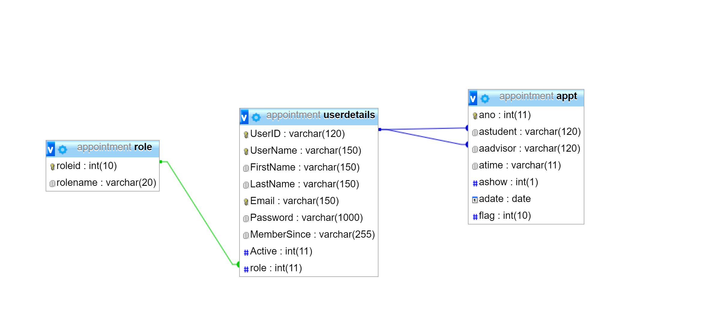

4. Snapshots

4.1 Index Page

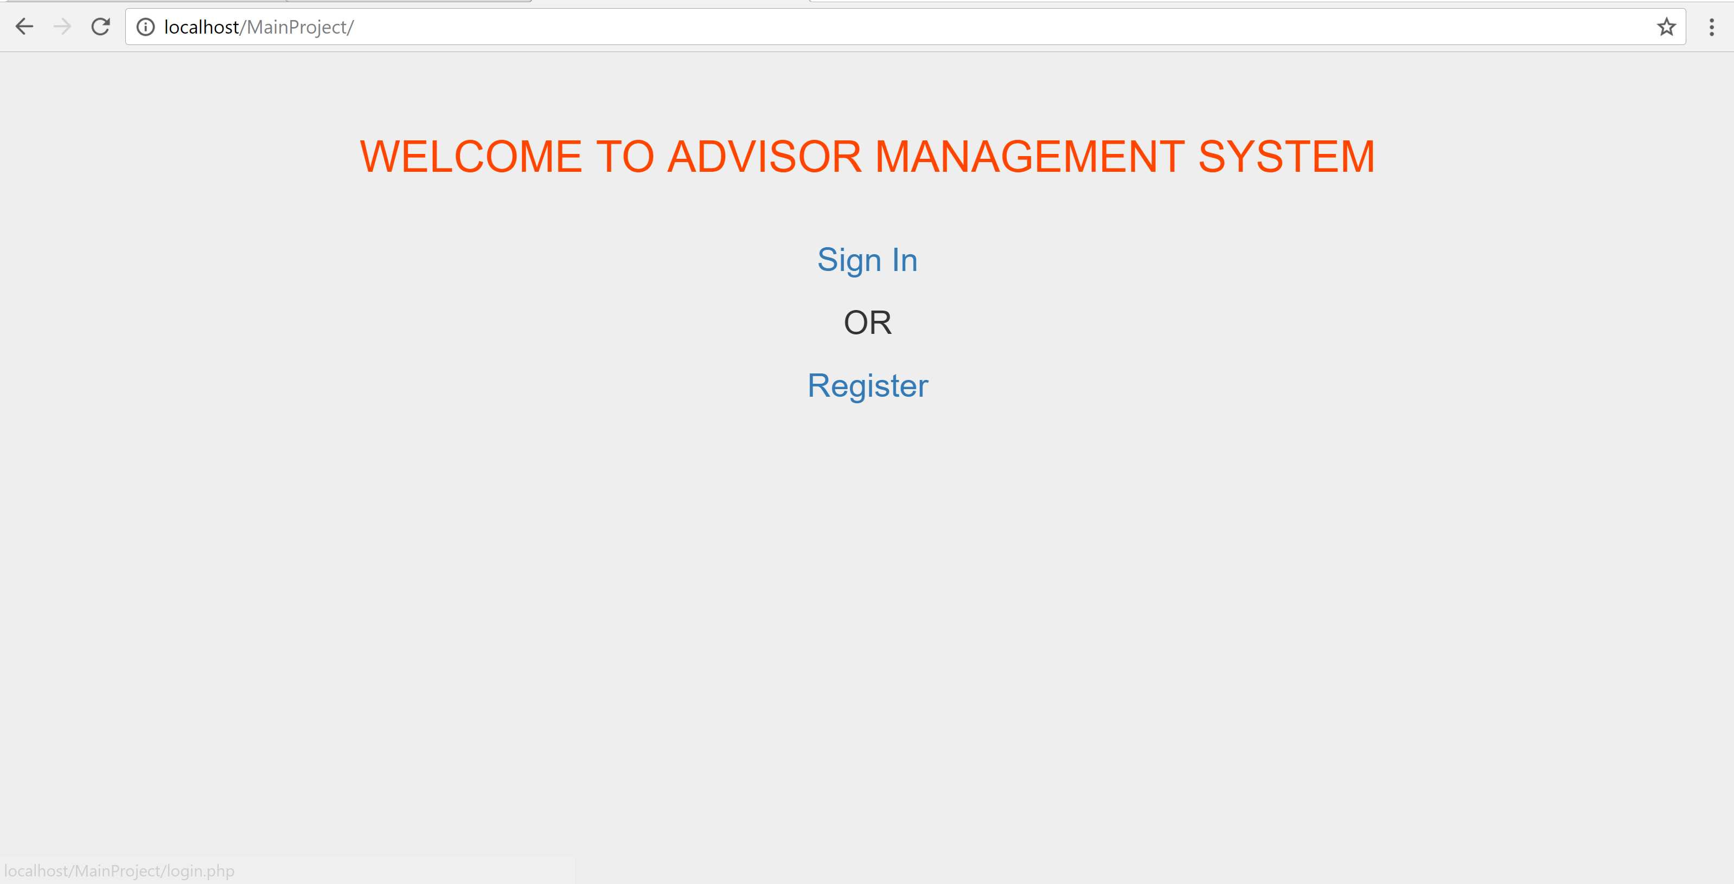

4.2 Register

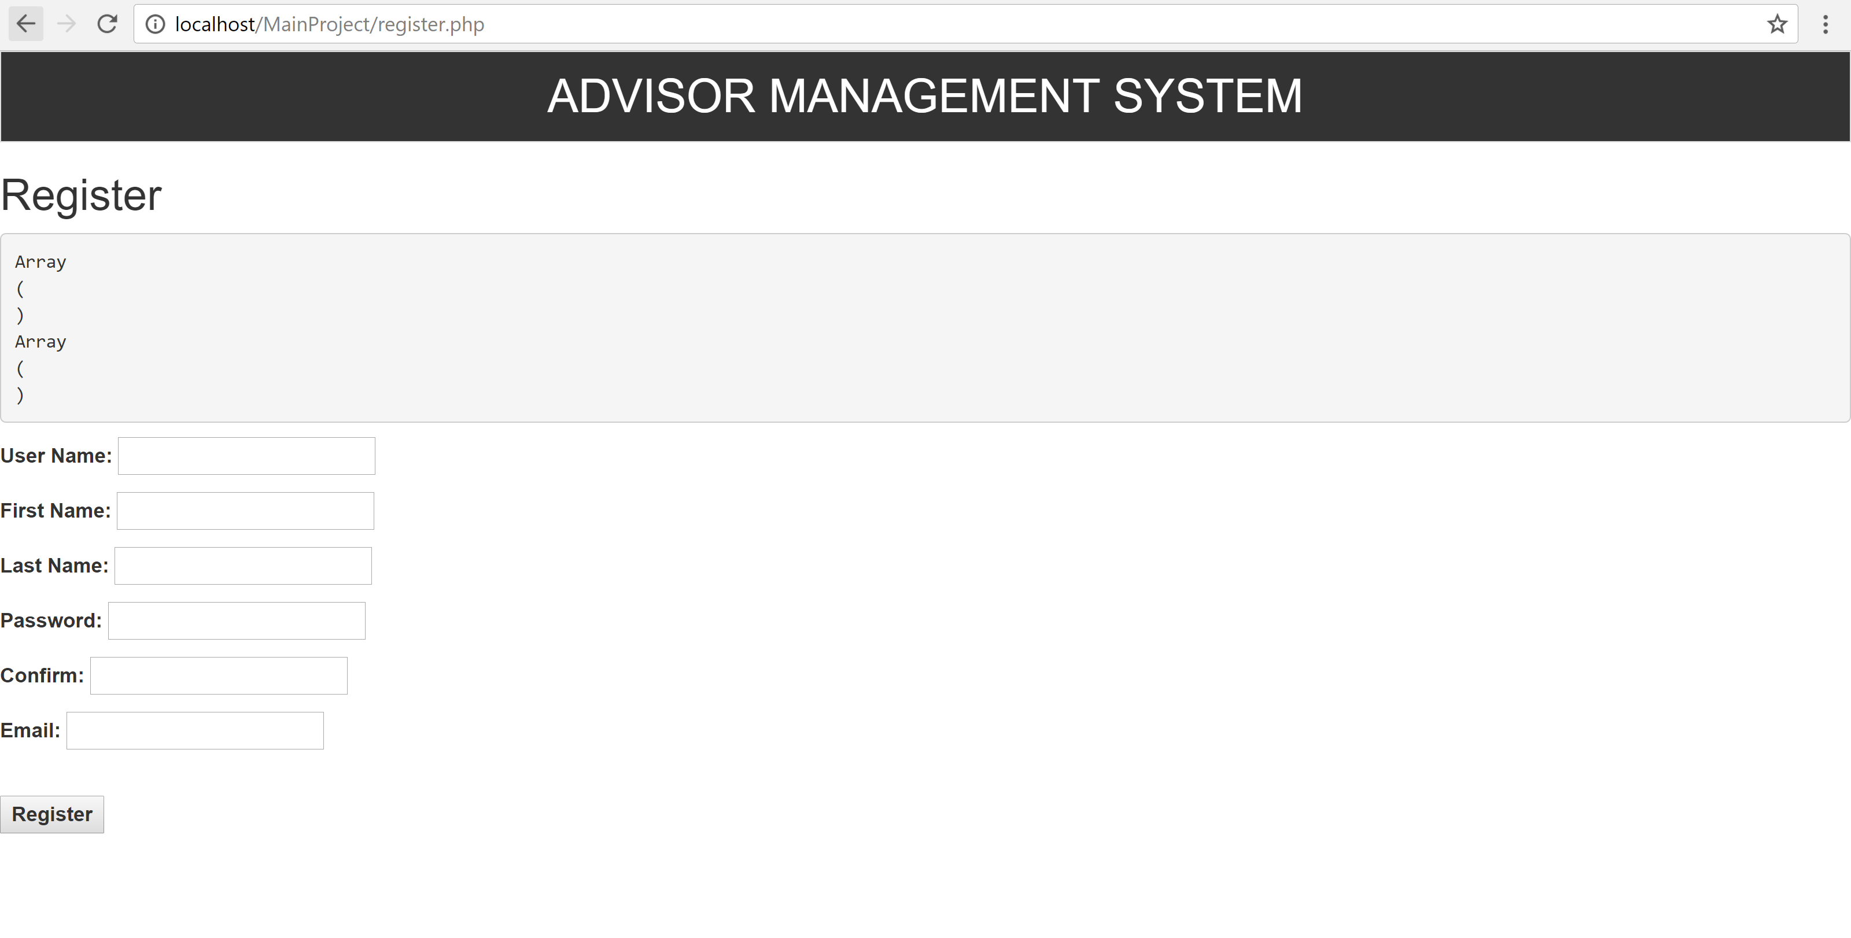

4.3Login Page

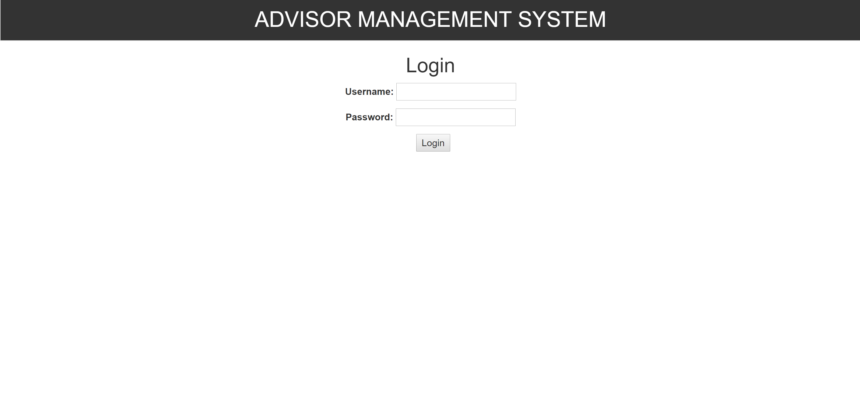

4.4 Admin Sign up Page

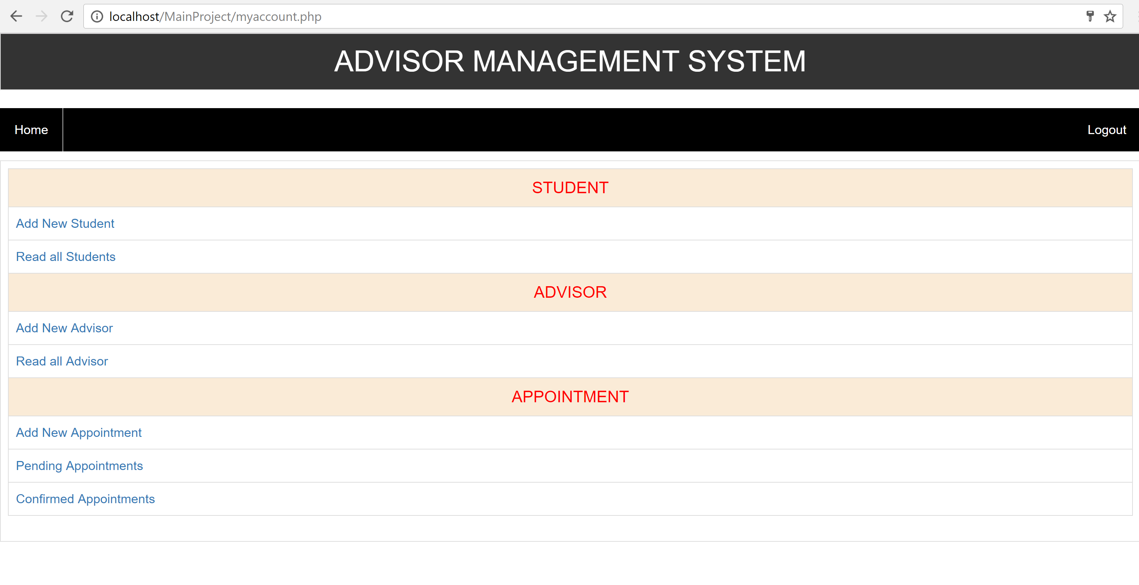

4.4.1Add New Student

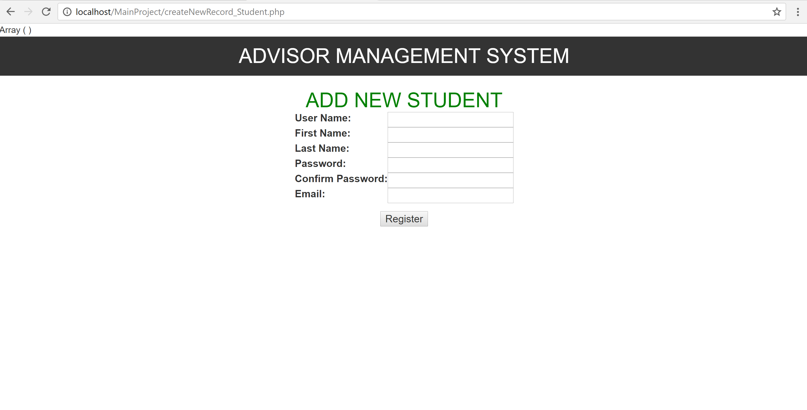

4.4.2 Read All Students

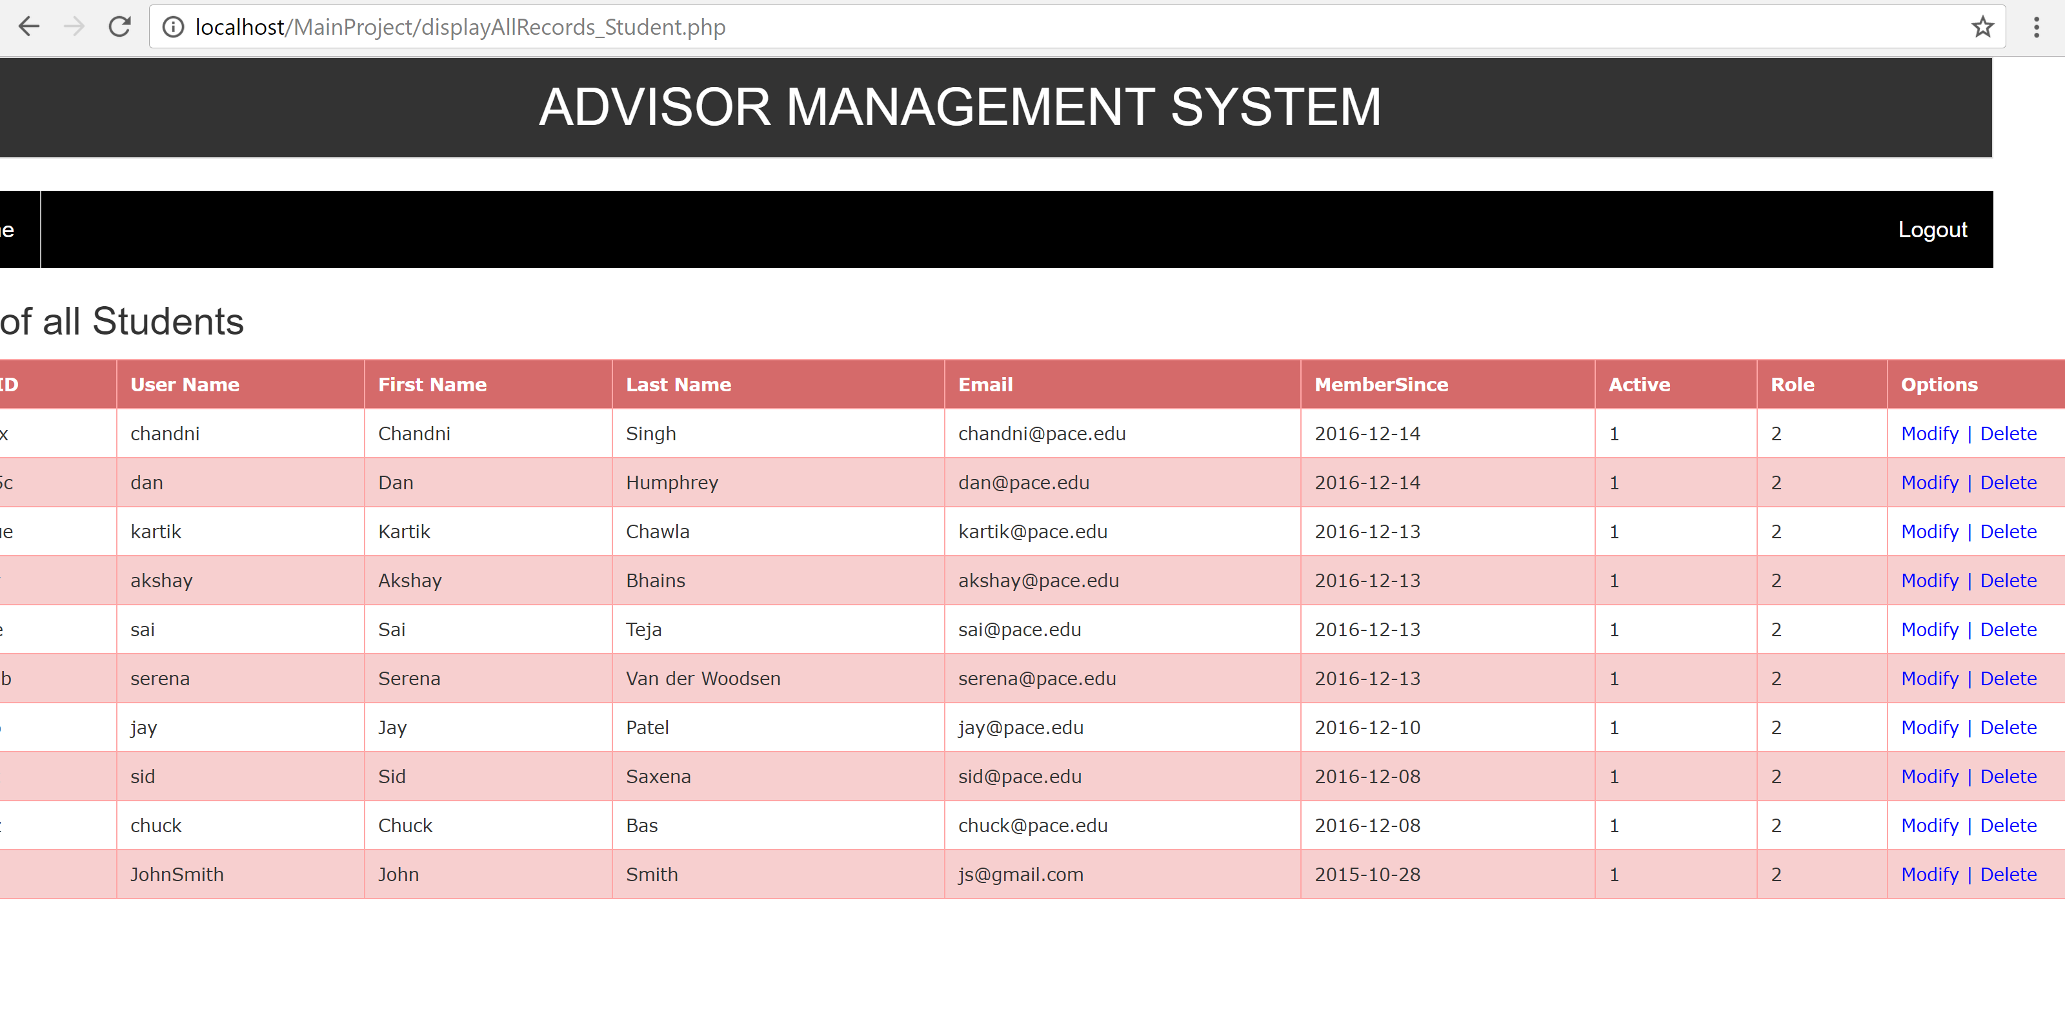

4.4.2.a Modify Student

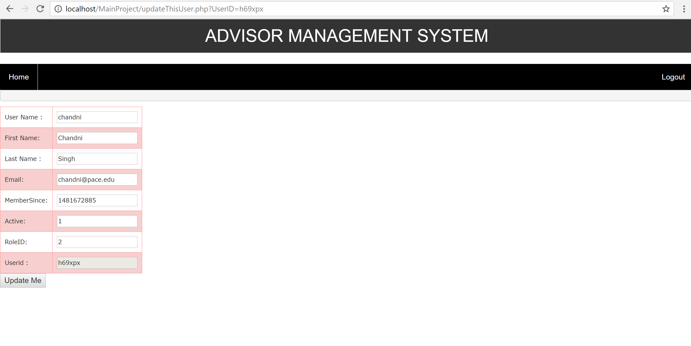

4.4.2.b Delete Student

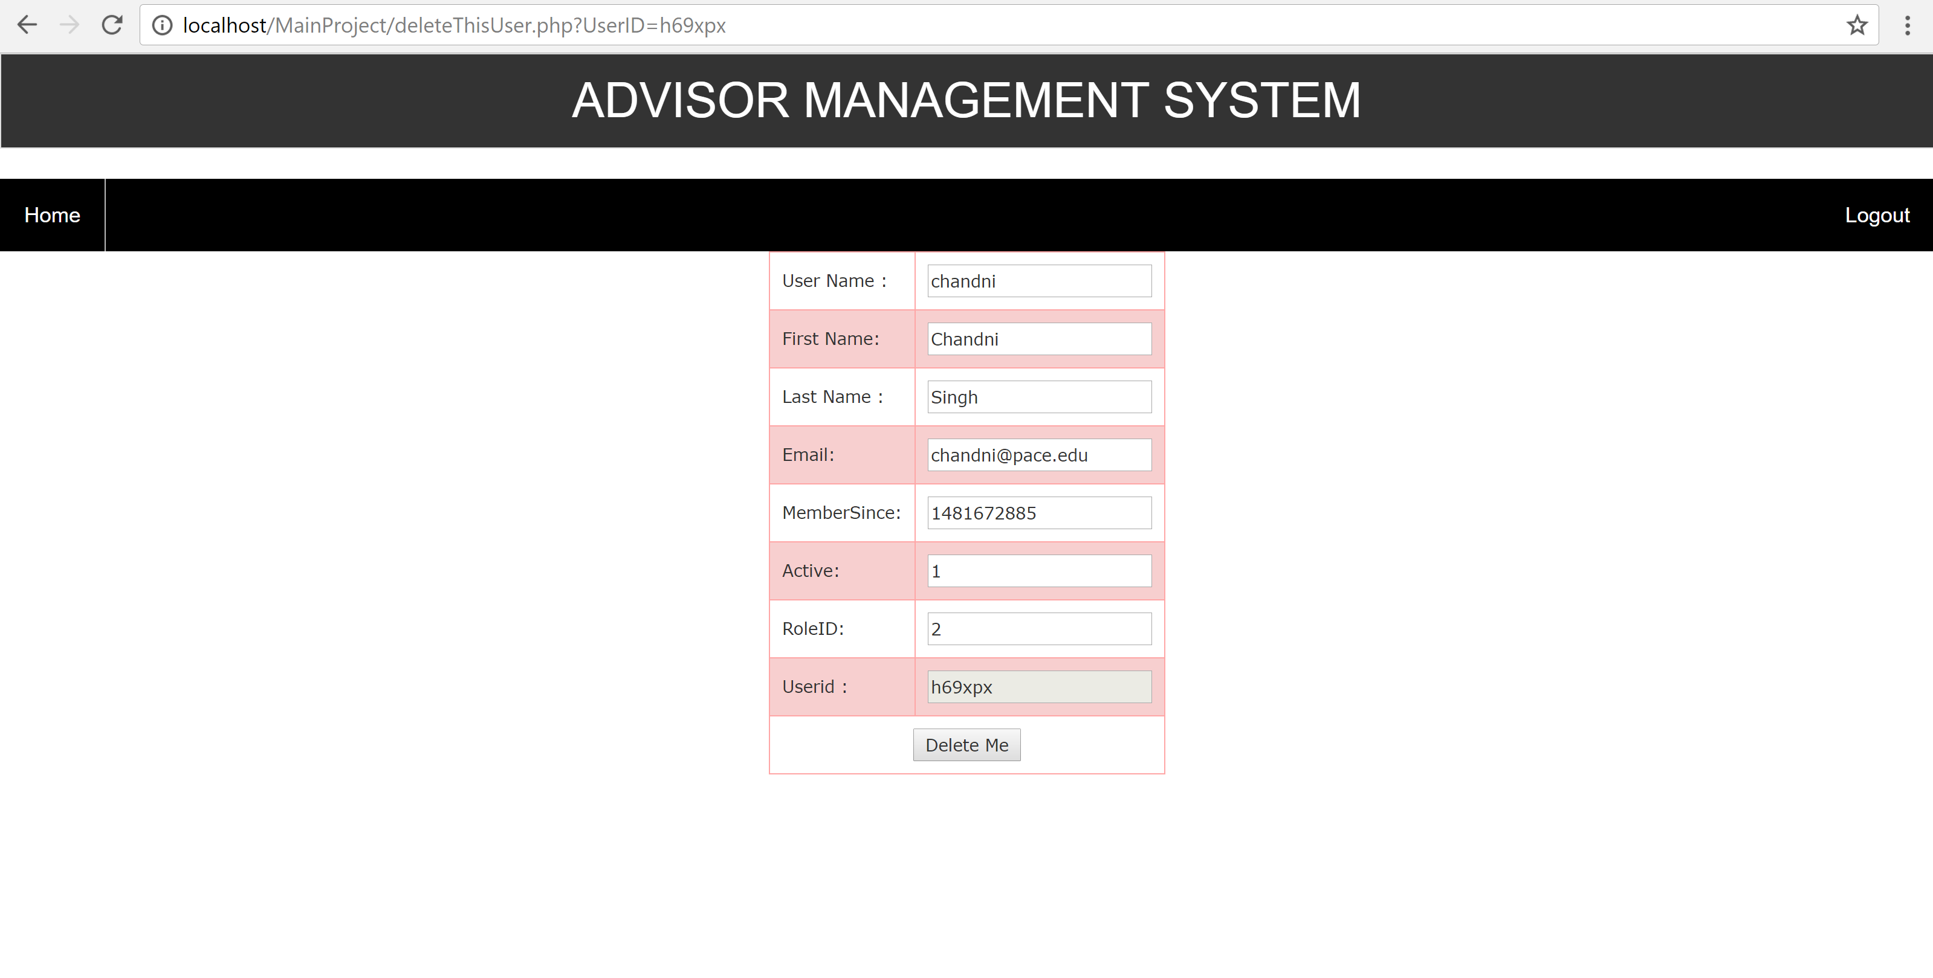

4.4.3 Add New Advisor

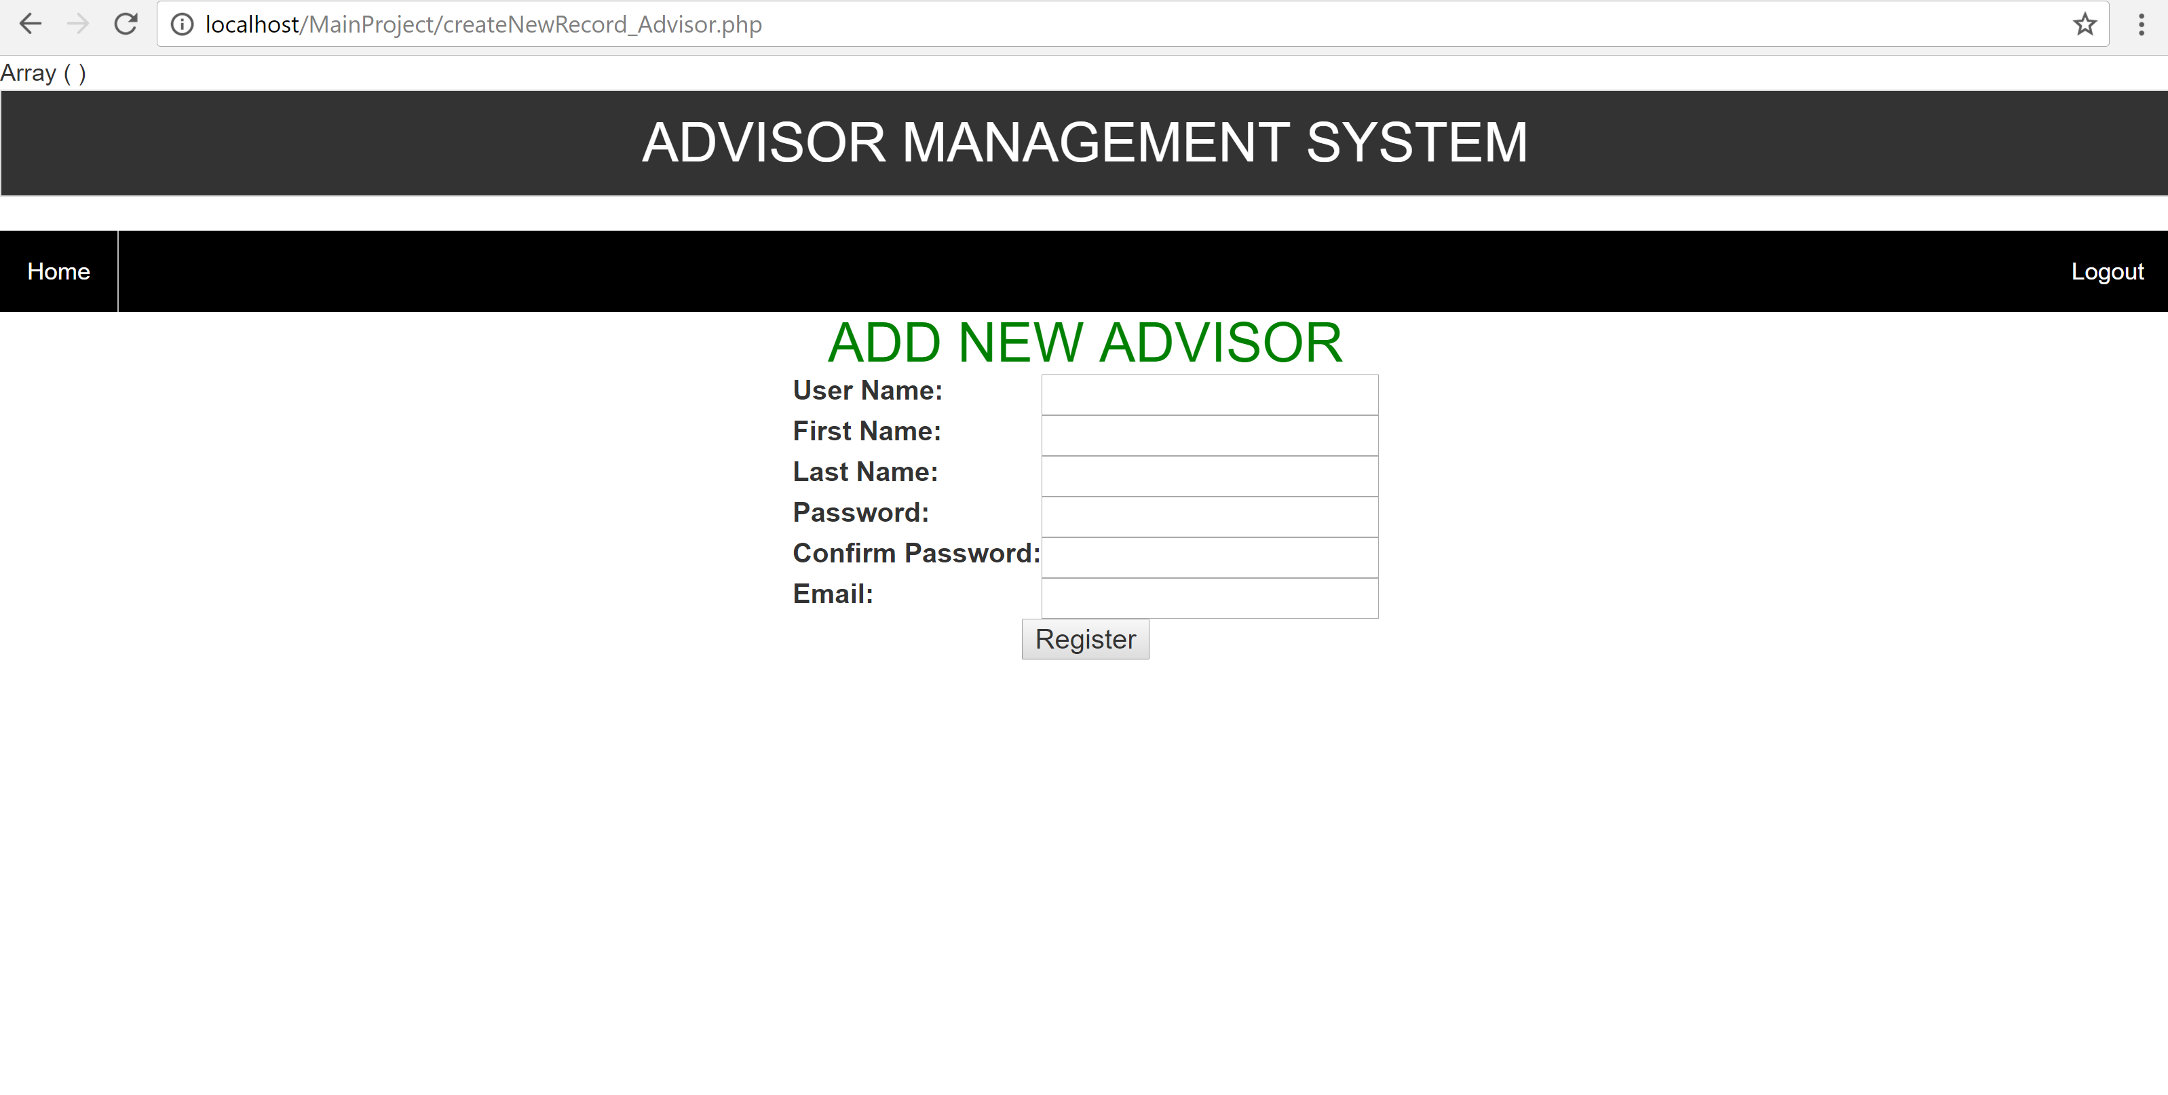

4.4.4 Read All Students

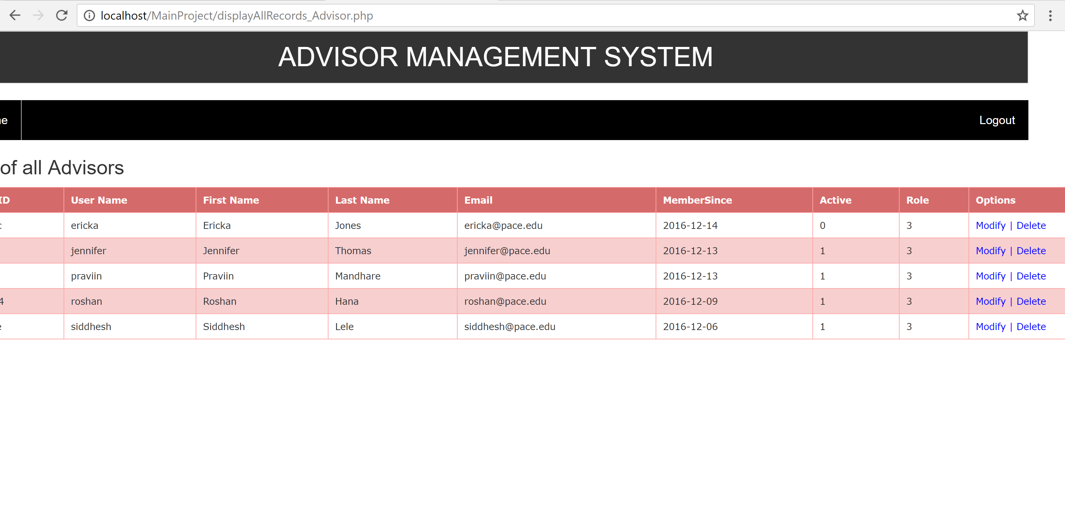

4.4.4.a Modify Advisor

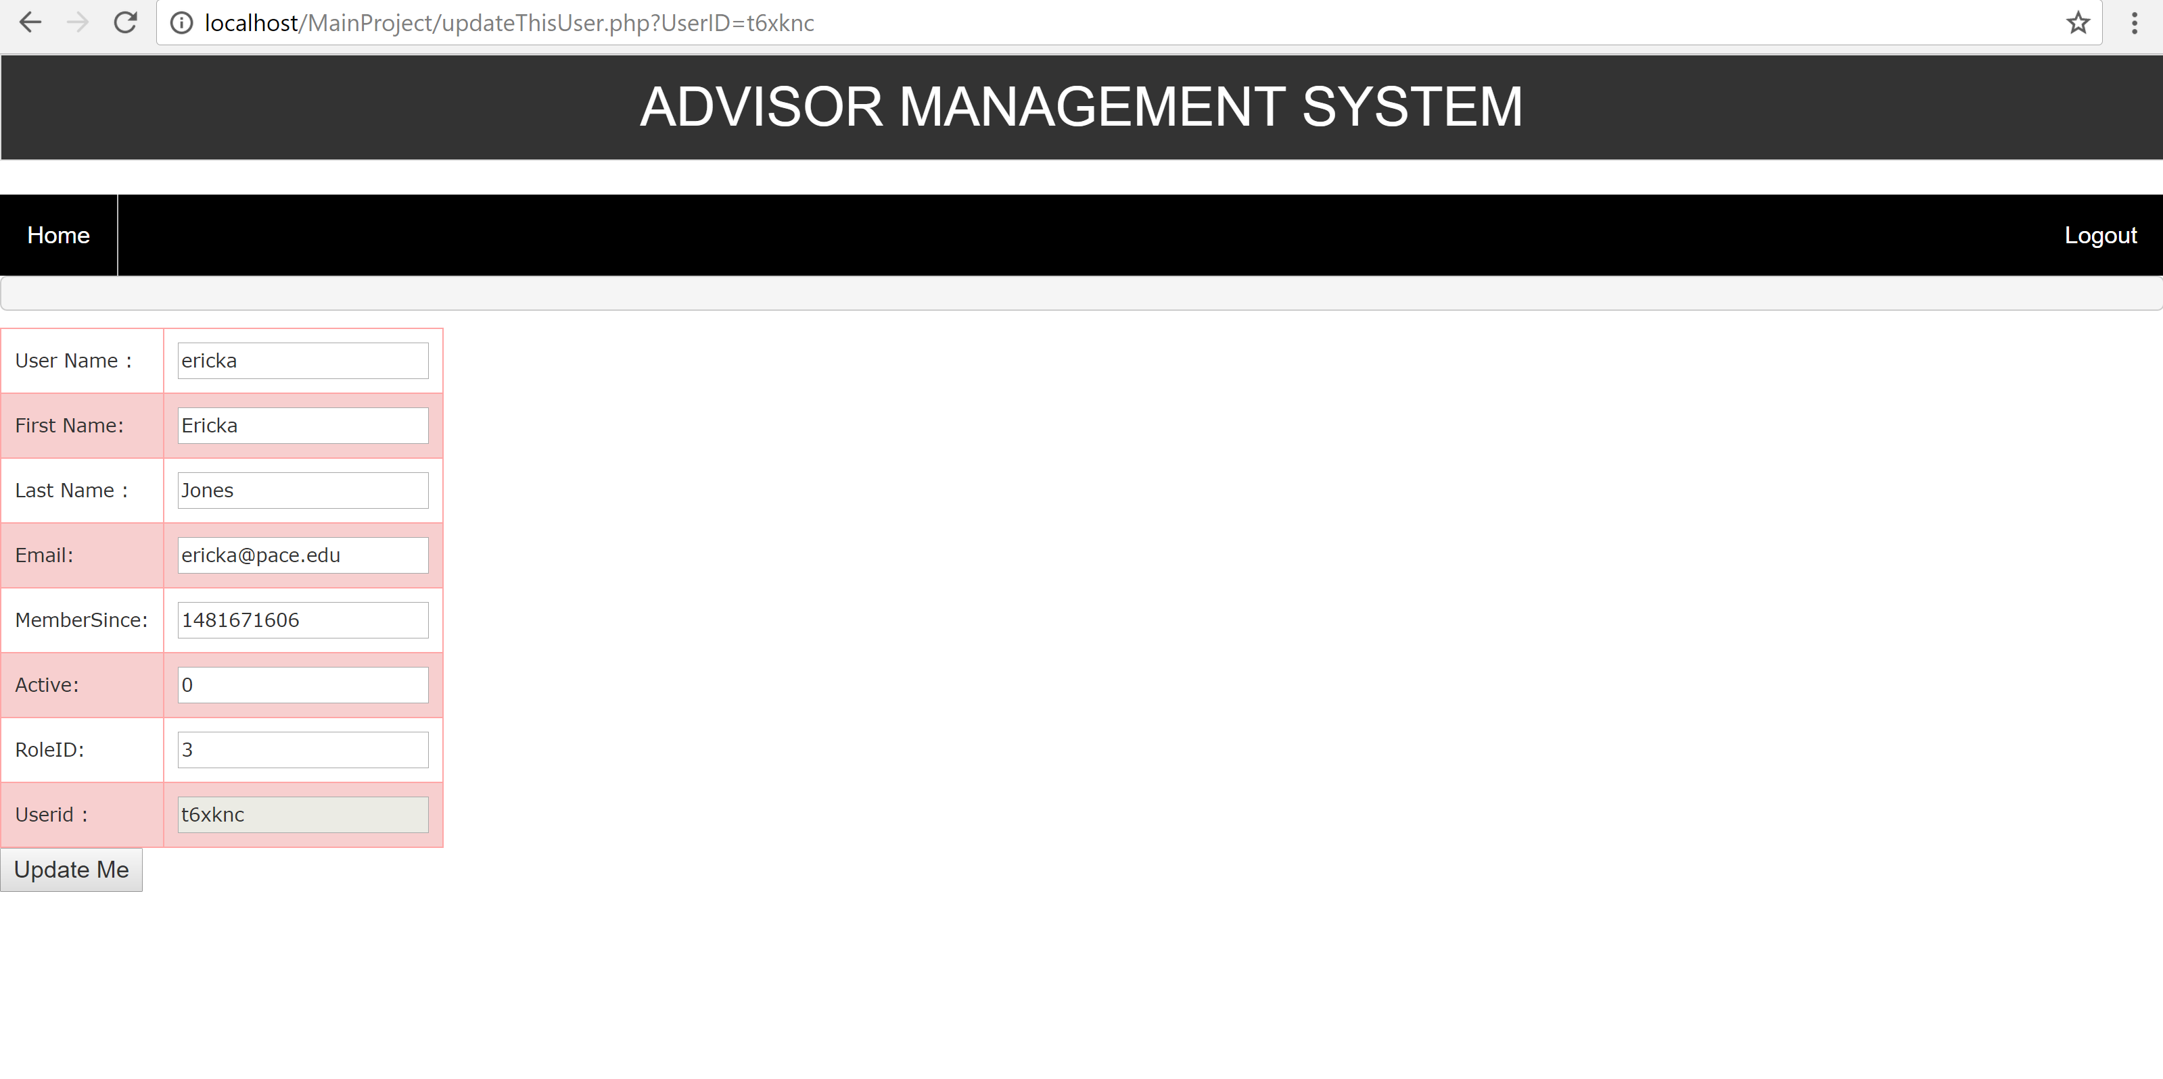

4.4.4.b Delete Advisor

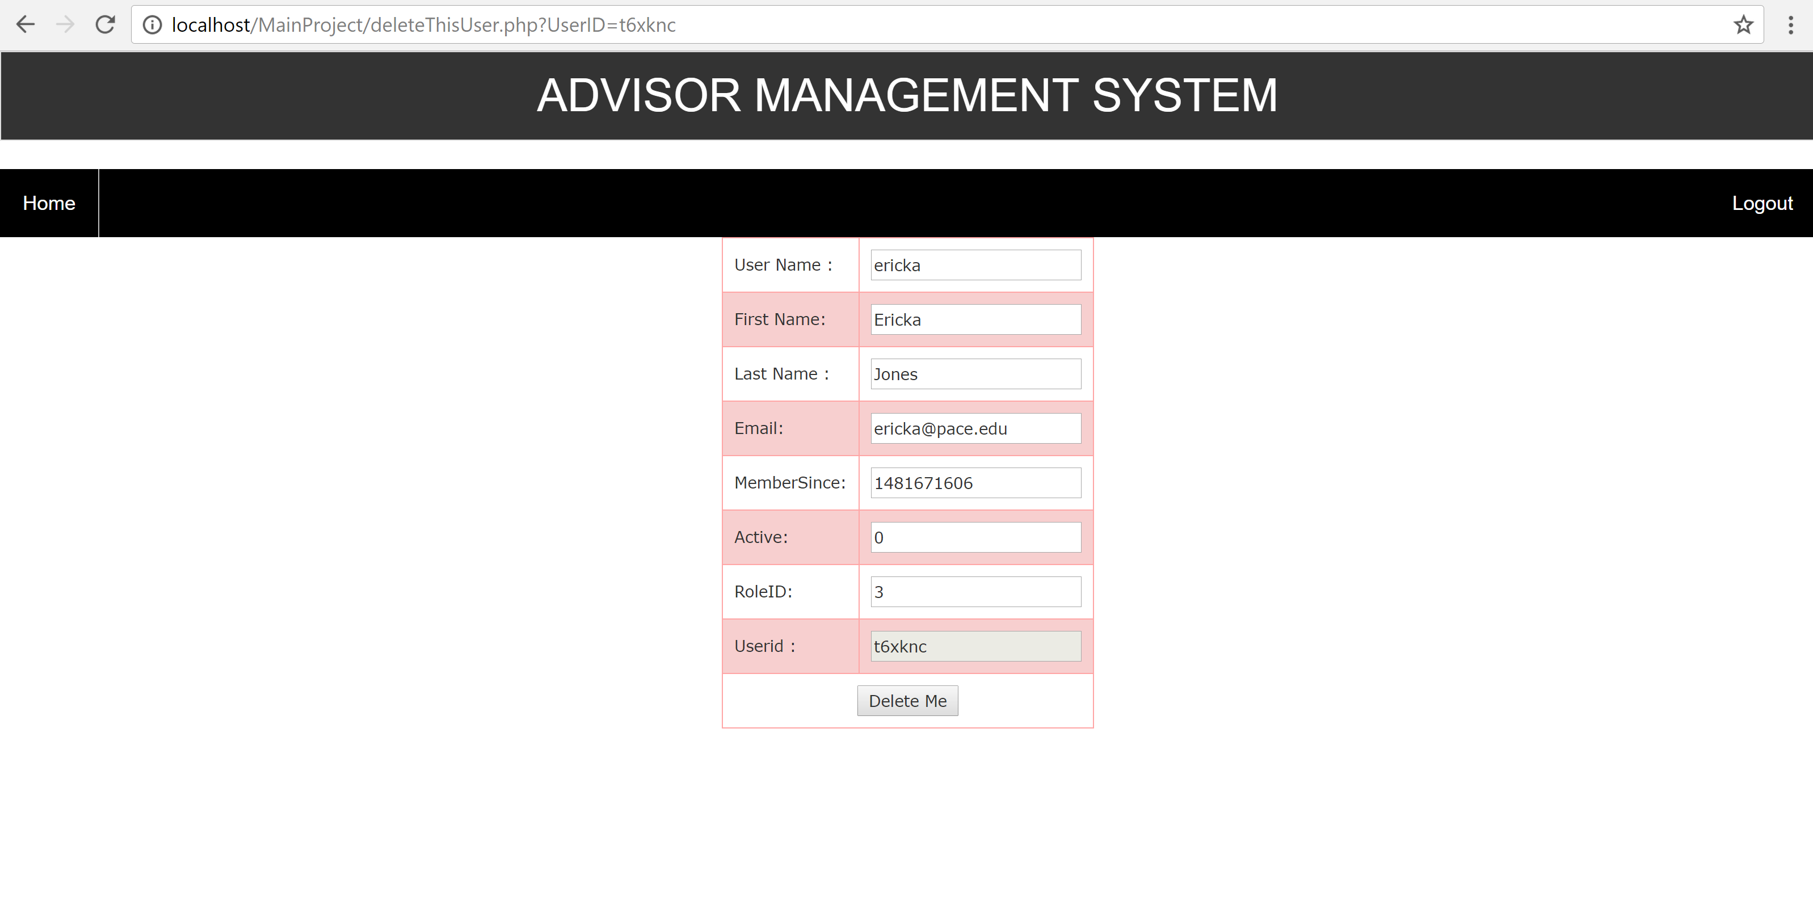

4.4.5 Add New Appointment

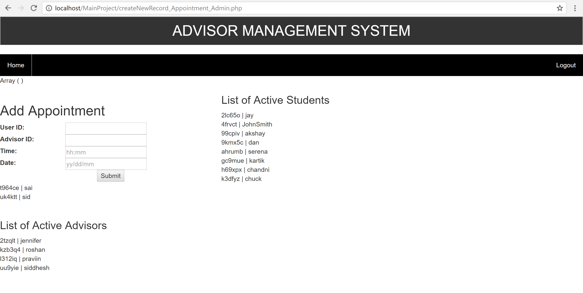

4.4.6 Pending Appointment

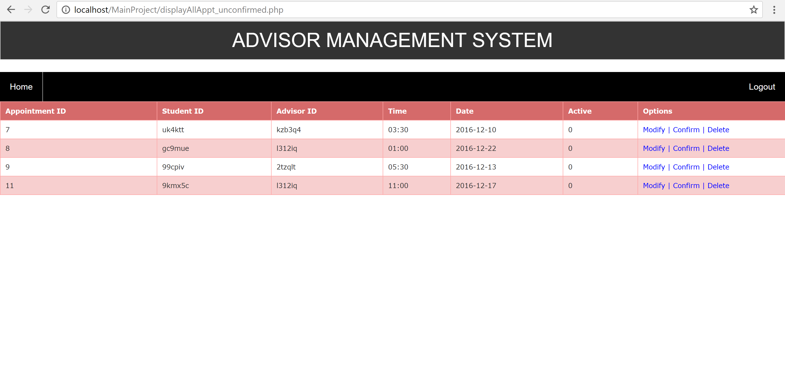

4.4.6.a Modify Appointment

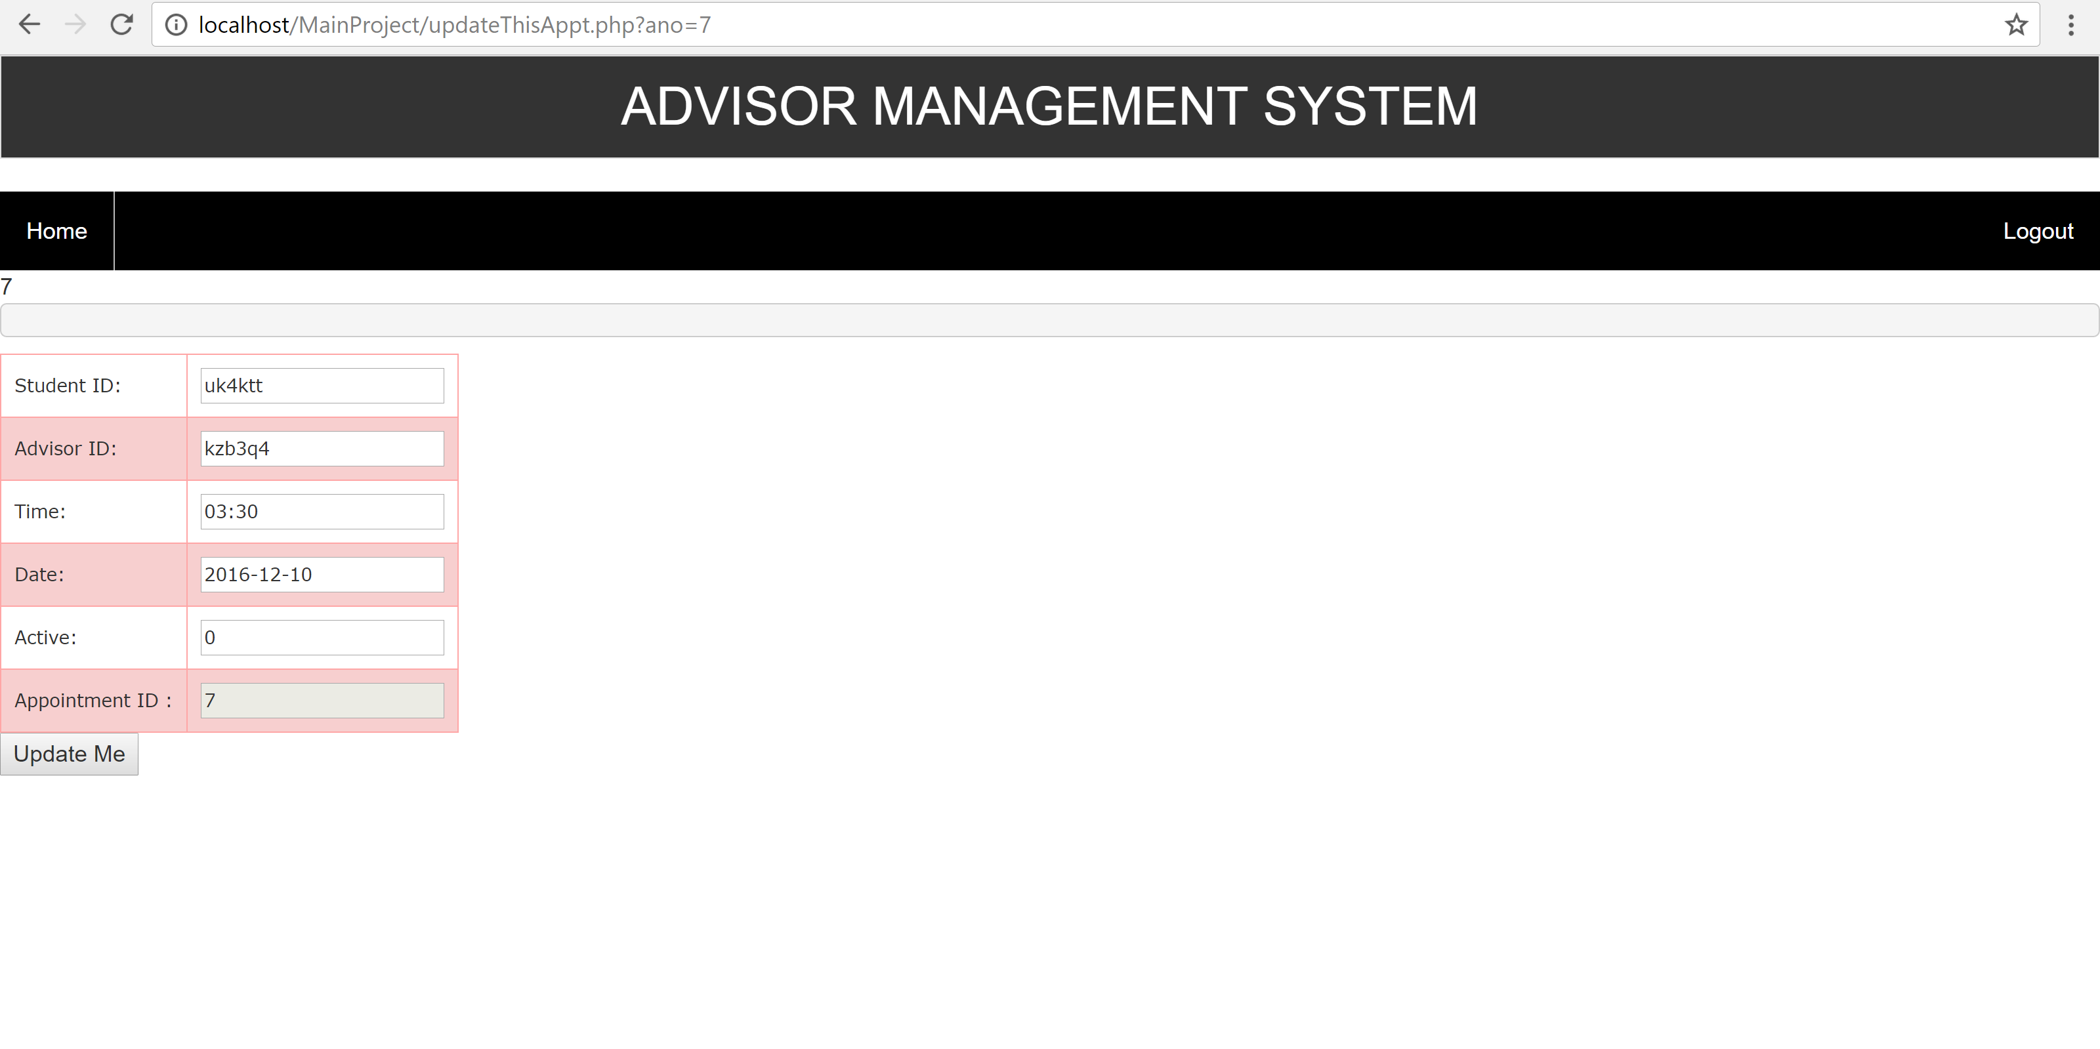

4.4.6.b Confirm Appointment

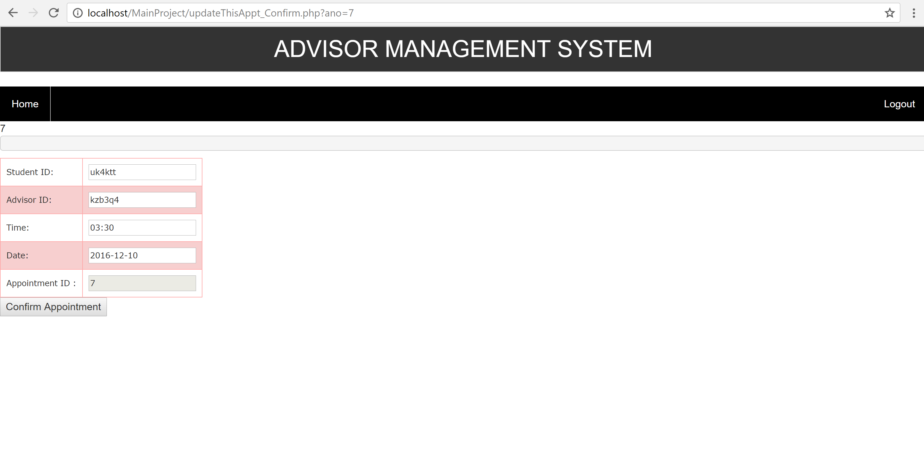

4.4.6.c Delete Appointment

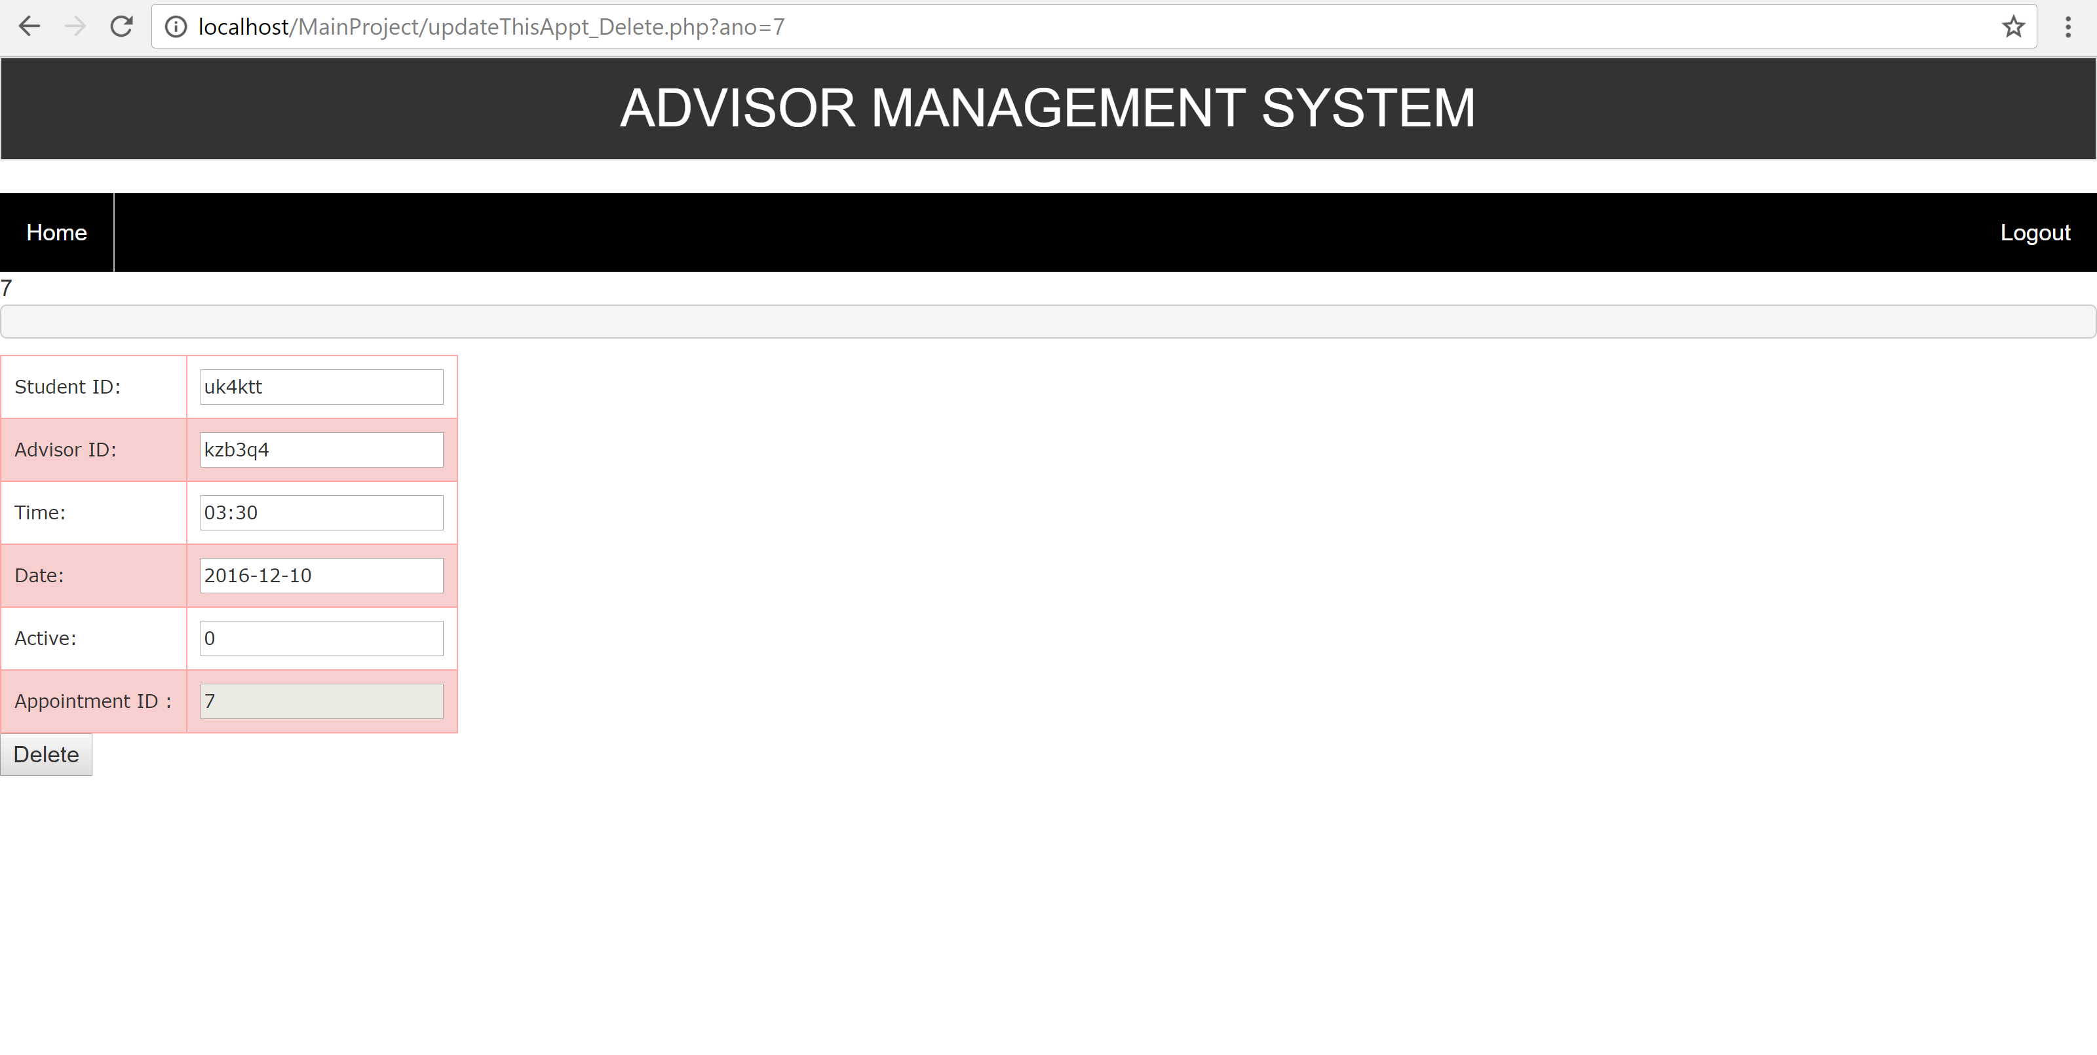

4.4.7 Confirmed Appointment

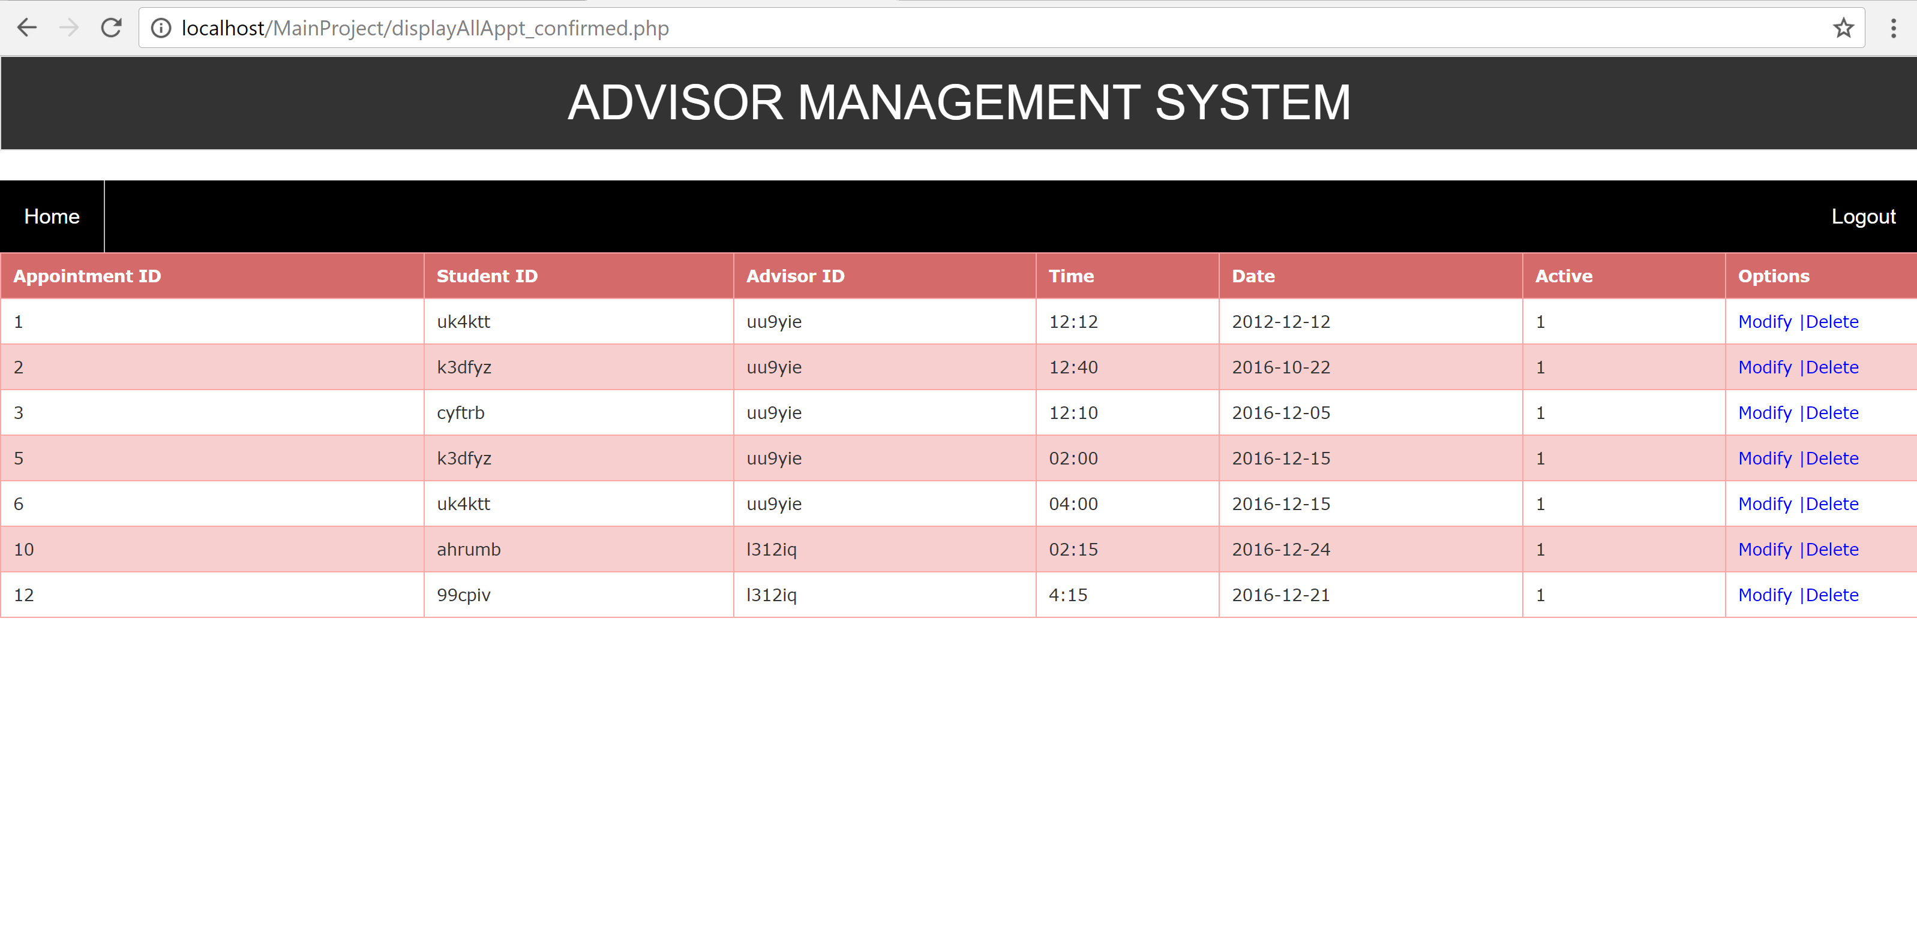

4.4.7.a Modify Appointment

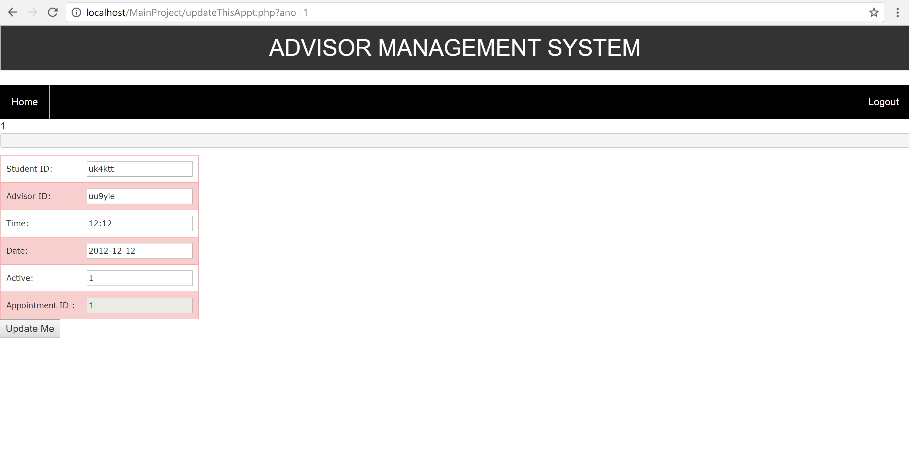

4.4.7.b Delete Appointment

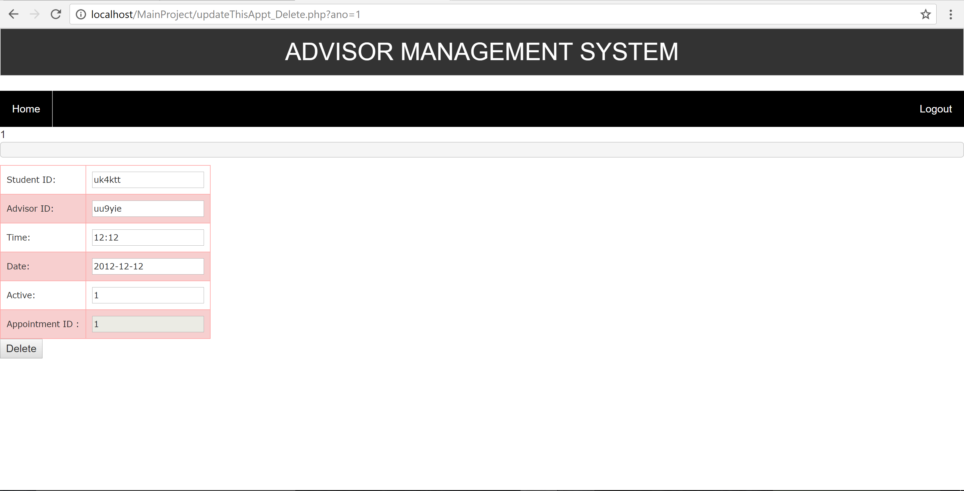

4.5 Student Sign up Page

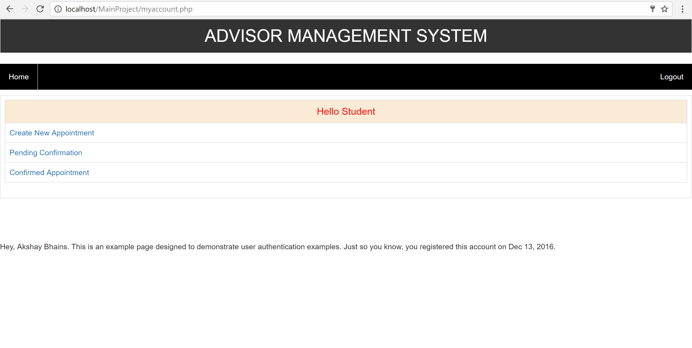

4.5.1 Add New Appointment

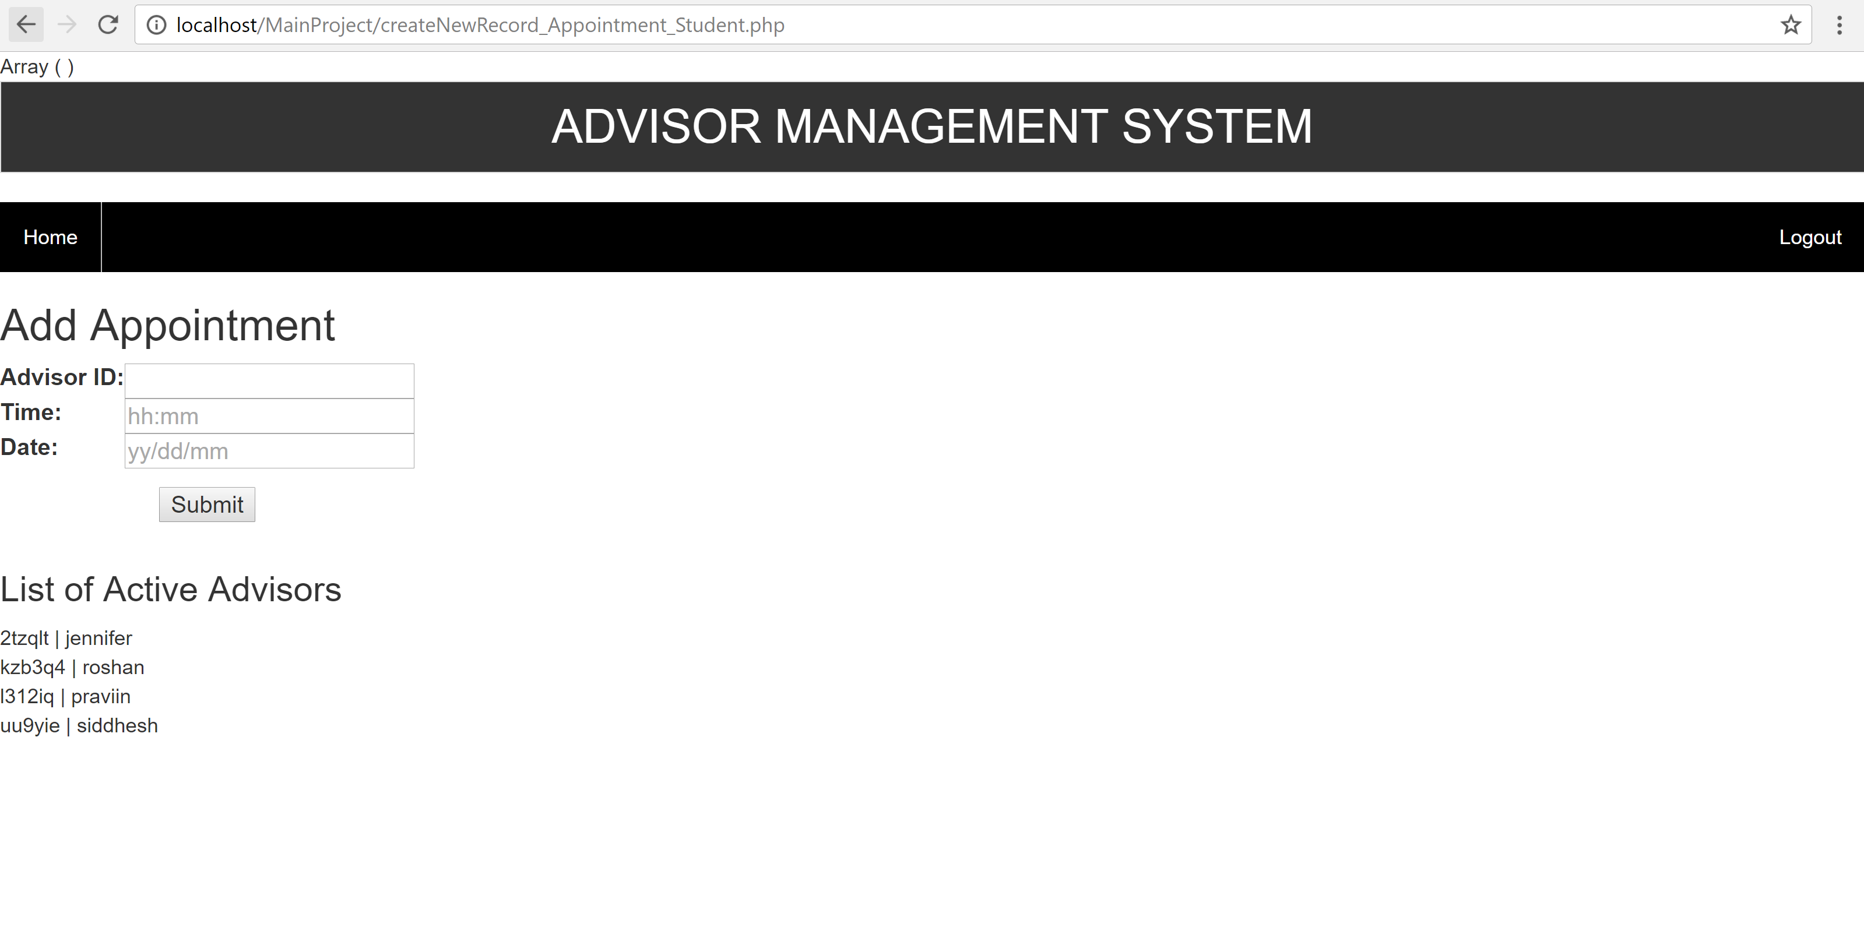

4.5.2 Pending Appointment

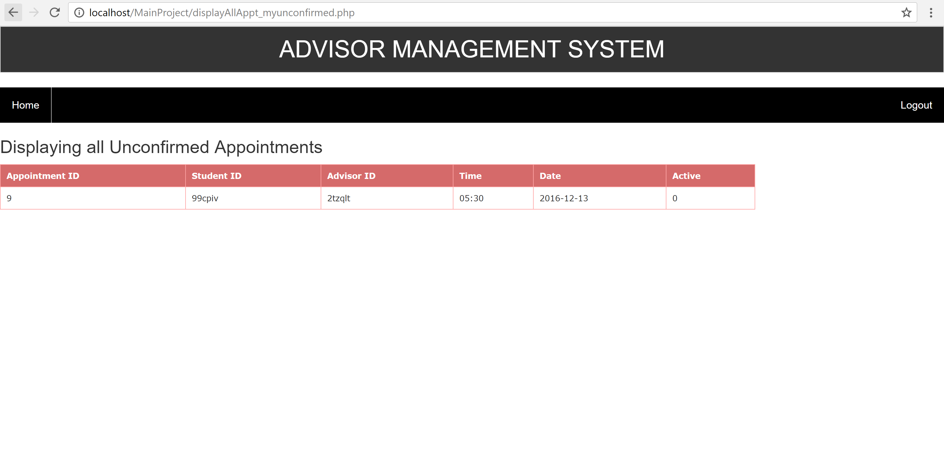

4.5.3 Confirmed Appointment

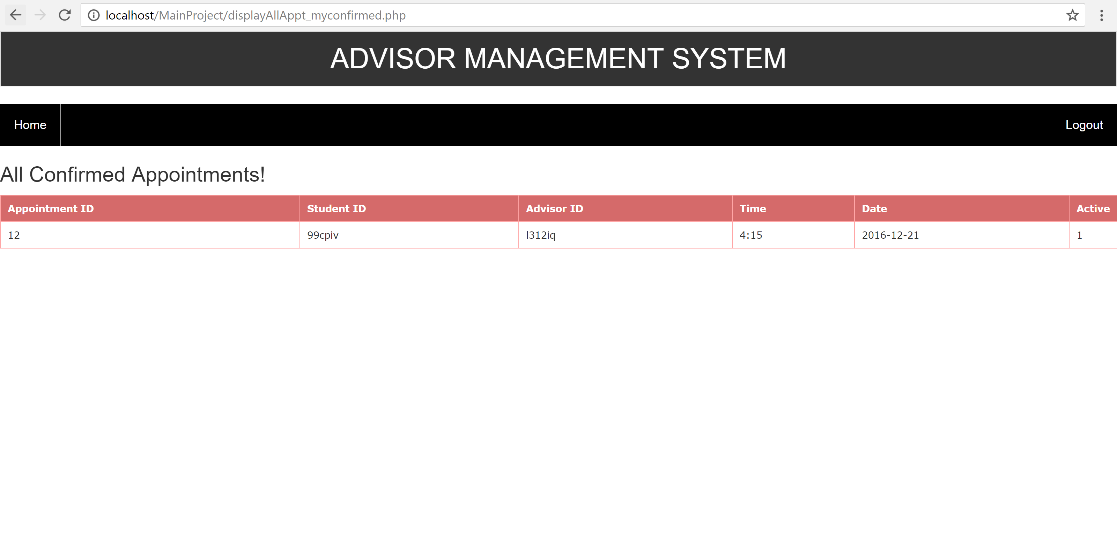

4.6 Advisor Sign up Page

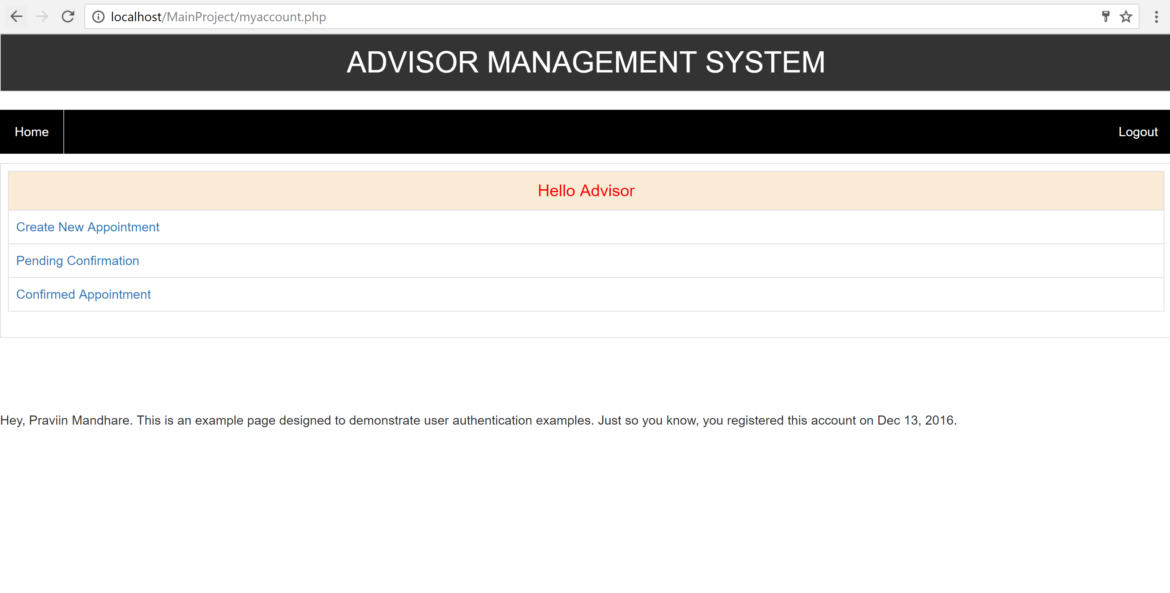

4.6.1 Add New Appointment

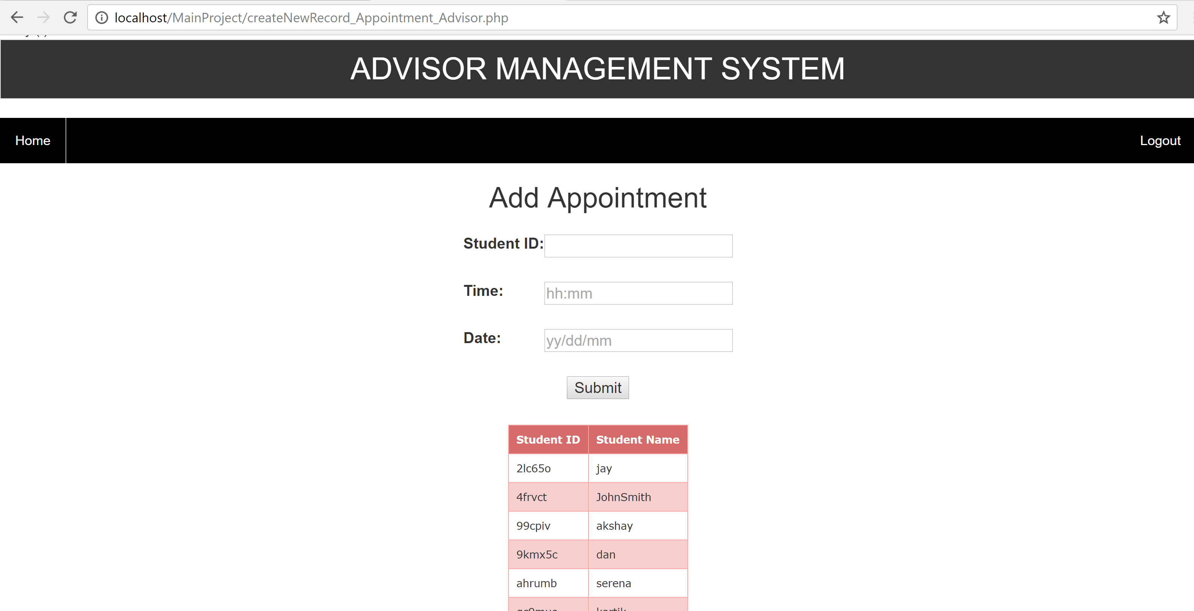

4.6.2 Pending Appointment

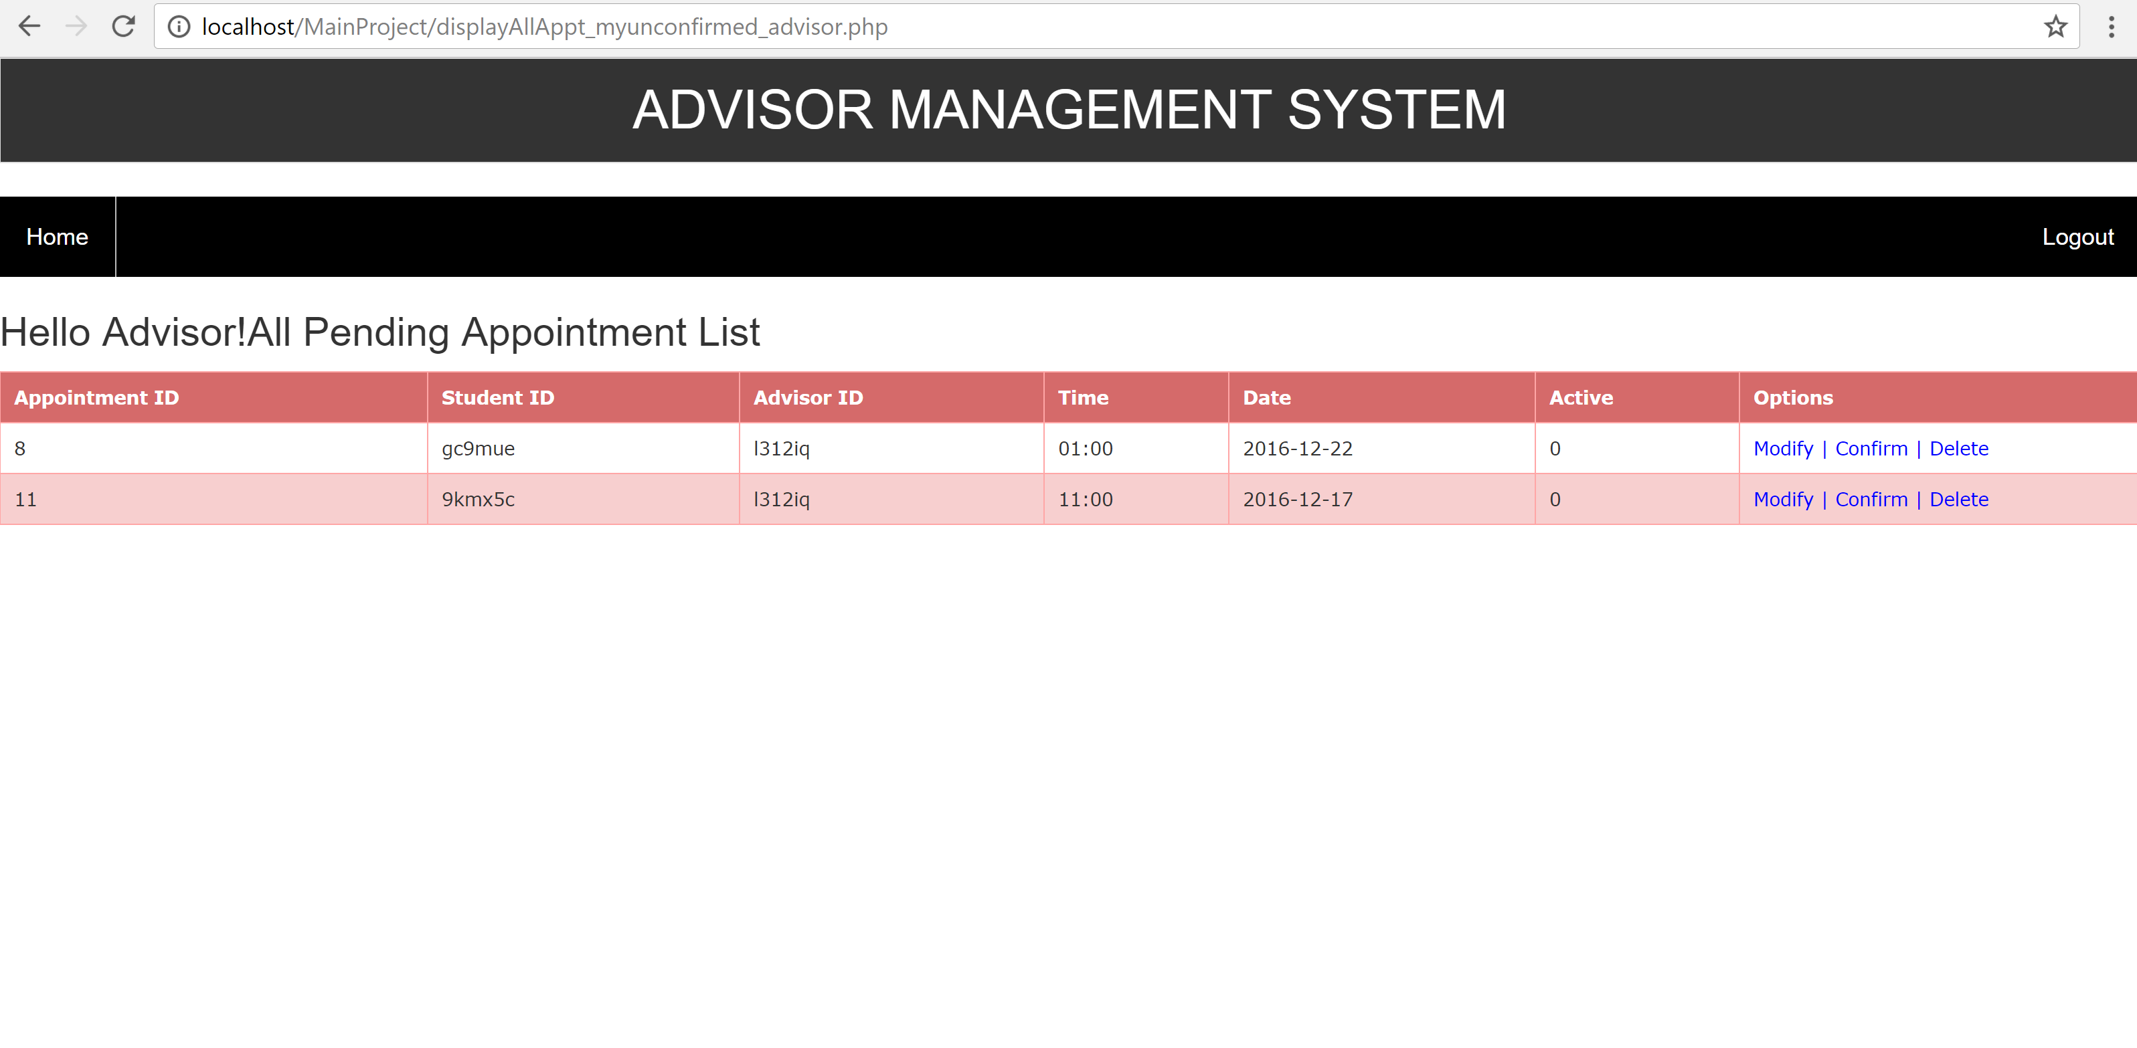

4.6.2.a Modify Appointment

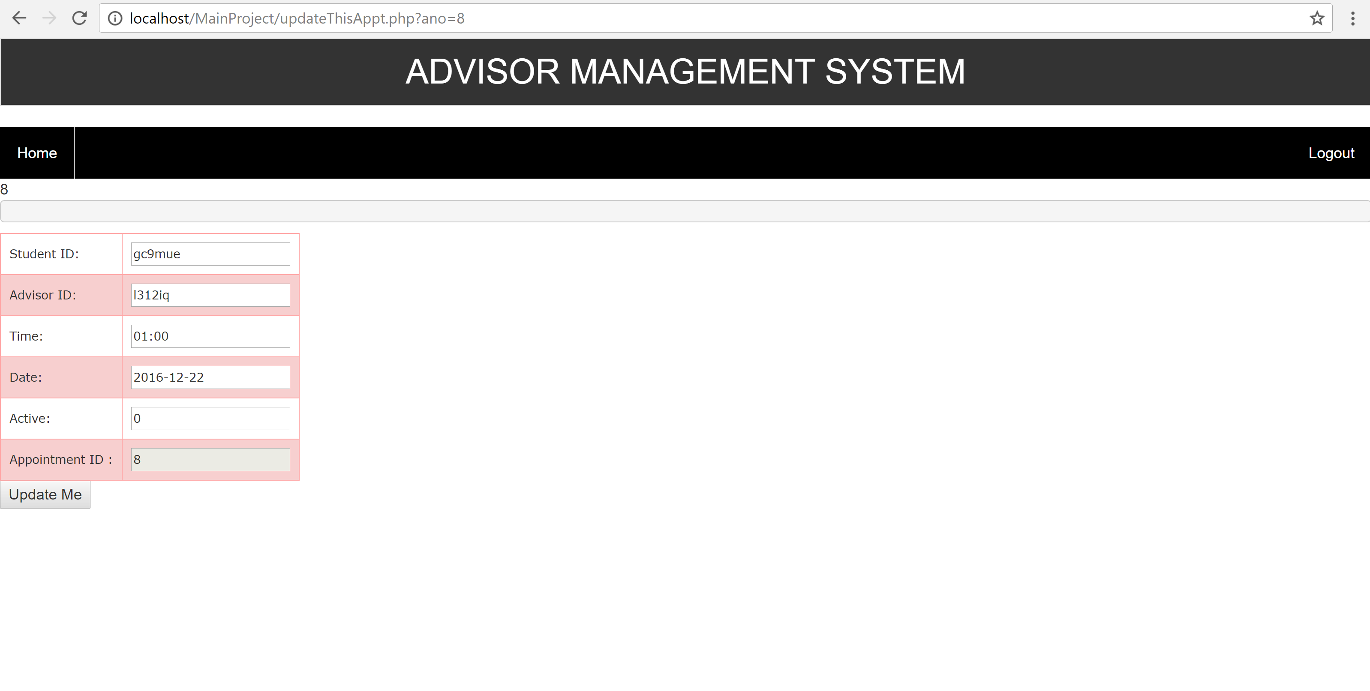

4.6.2.b Confirm Appointment

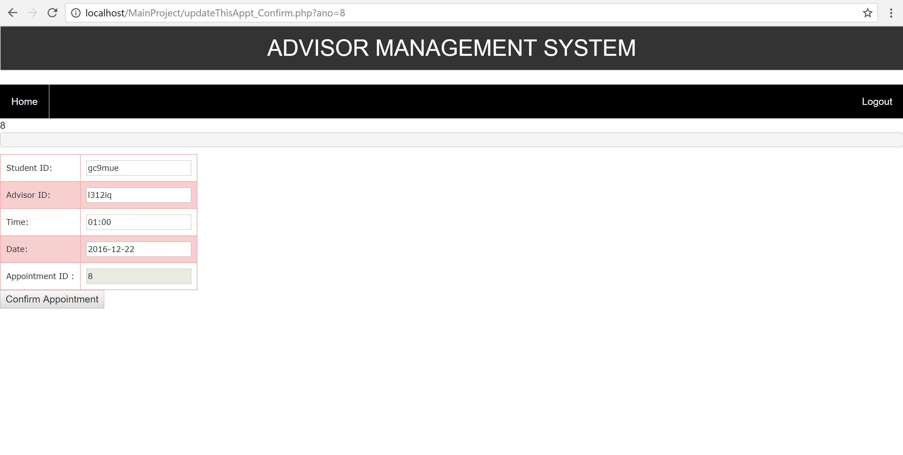

4.6.2.c Delete Appointment

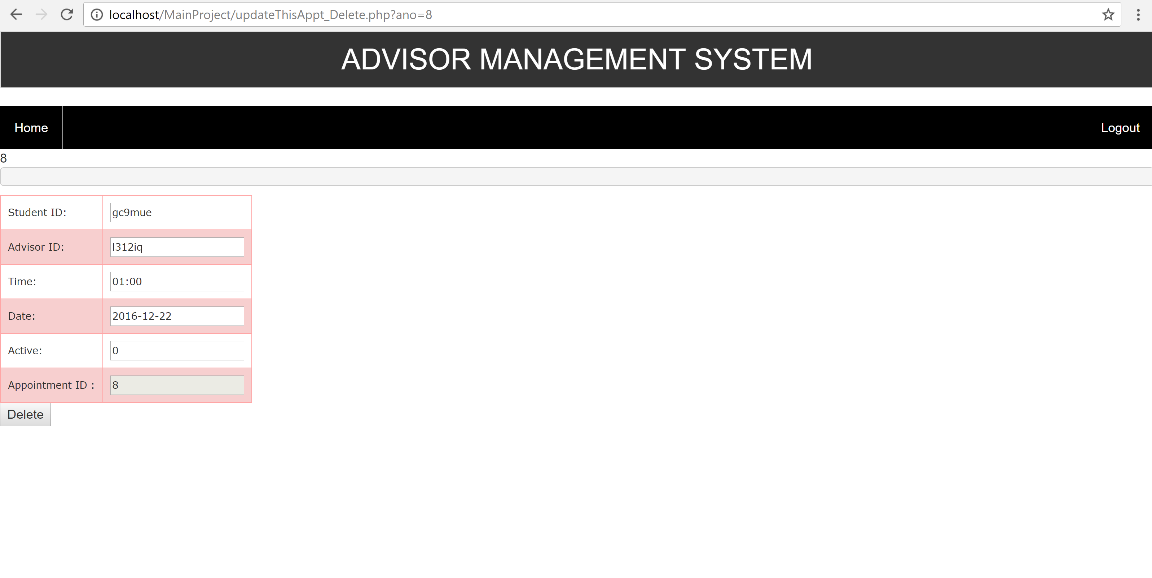

4.6.3 Confirmed Appointment

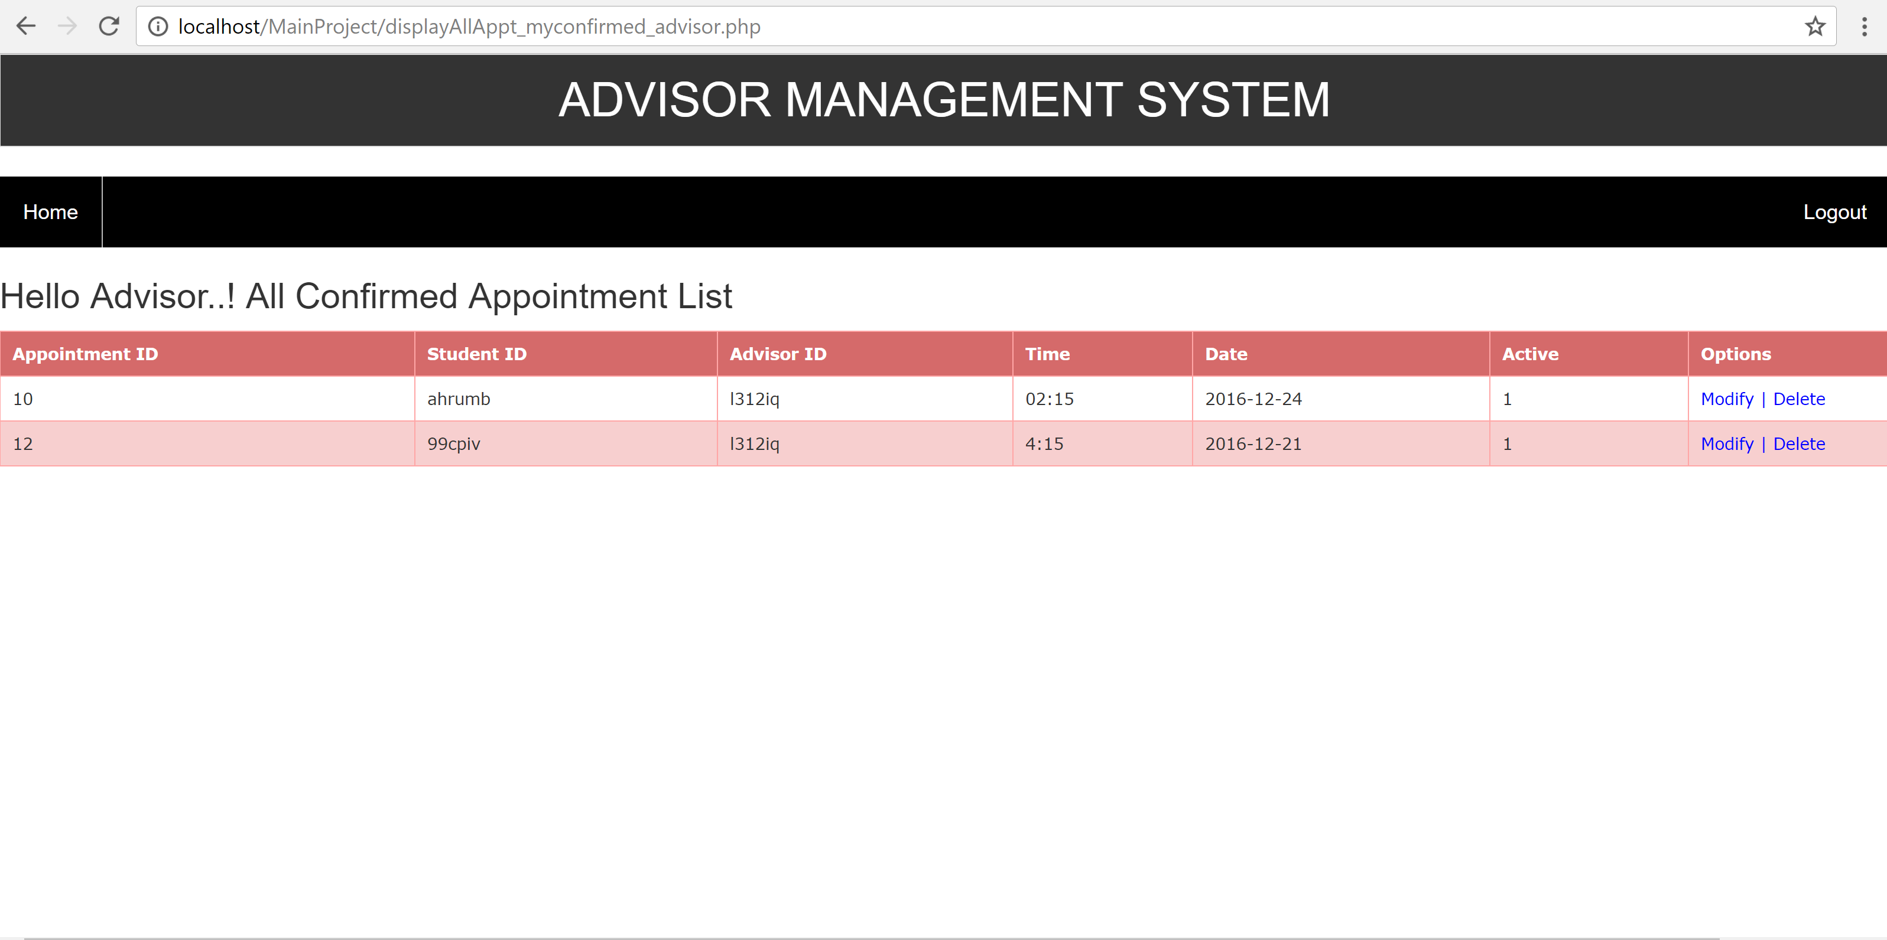

4.6.3.a Modify Appointment

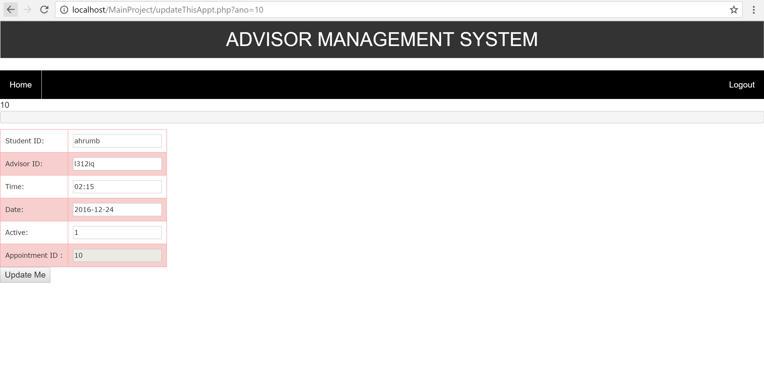

4.6.3.b Delete Appointment

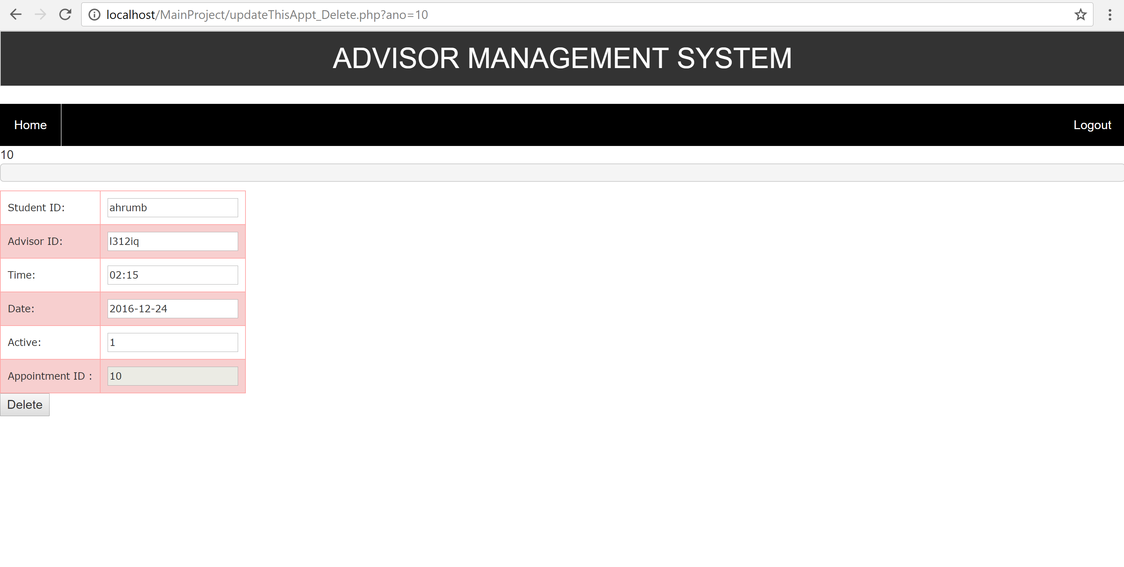

Conclusion

We felt that the improvement of an online appointment management system was important as a result of the out of date path in which many schools enlist and timetable student arrangements. So as to stay aware of developing innovation, we should look for approaches to make certain procedures less tedious, more blunder free and more easy to use. We have assembled the framework utilizing PHP. A field contemplate has been done to watch the elements of our framework and partners' use. Moreover, our online arrangement administration framework has been contrasted and another static appointment management.